**KAMEL OTOOM**

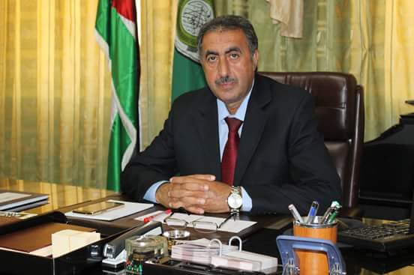**Personal info**

Date of Birth: 19.7.1958

Address: Jerash – suf

Contact info:

Phone: 00962-772171764

Email: [aakaotoom@yahoo.com](mailto:aakaotoom@yahoo.com)

**Education:**

* PhD in Curriculum and Instruction / Arabic Language; University of Jordan ;( 2001- 2004)
* Master of Curriculum and Teaching; University of Jordan (1992-1995)
* High Diploma of Arabic Language Teaching Methods; Yarmouk University ;( 1986-1987)
* Bachelor of Arabic Language; University of Jordan (1976- 1980)

**Practical experiences:**

* Lecturer at the Faculty of Educational Sciences at Jerash University(Oct .2004 - until now.
* Dean of the Faculty of Educational Sciences; Jerash University (Feb. 2016, - Aug 2016)
* Dean of Student Affairs; Jerash University (March.2015 – Feb.2016)
* Head of the Department of Curriculum and Teaching at the Faculty of Educational Sciences; Jerash University (Oct. 2014 – March 2015)
* Head of the Department of classroom teachers at the Faculty of Educational Sciences; University of Jerash (Oct.2011- Oct.2012)
* Head of Curriculum and Teaching Department at the Faculty of Educational Sciences; Jerash University (Oct. 2012- Oct.2013)
* Supervisor of the Arabic language; Jordanian Ministry of Education (1995-2004 )
* High School Director ; Jordanian Ministry of Education ;(1993-1995)
* Teacher of Arabic language for the secondary stage; ; Jordanian Ministry of Education (1982-1993)
* Preparation of a test for the State of Qatar with the "ETS" American Center.
* Trainer of professors of Jerash University on modern teaching strategies.

**Conferences**

* The Future of Education in the Arab World in the Light of the Information Revolution: Jerash University: April 2008: Presented a paper entitled "The Experience of the Ministry of Education in Jordan in the field of e-Learning".
* The Role of the Arab Teacher in the Age of Knowledge Flow: Jerash University: April 2009: A research paper entitled "Teachers of Jarash Governorate and Educational Research: Their Awareness of Their Role as Researchers and their Research Practices, and the Implications of this Role on Students and their Obstacles".
* Education and the present and future society - Jerash University.
* The National Conference for the Development of Study Plans and Teaching and Learning Methods: organized by the Jordanian Ministry of Higher Education at the Royal Hotel on 15-17 June 2010.
* The Fifth Scientific Research Conference in Jordan held by the Jordanian Association for Scientific Research at the Landmark Hotel on Saturday 19 November 2011,
* Conference on the launch of competencies kindergarten teacher held by the Ministry of Education at the Meridian Hotel on the day 28/1/20112.
* Conference on Arab Child Education in the Age of Globalization: Challenges and Aspirations Jerash University: June 2012: Presented a paper entitled "The challenges of globalization affecting the work of educators in Jerash Governorate".
* Arab school reality and challenges - Jerash University.
* The National Conference of MEDAWEL TEMPUS PROJECT organized by Princess Sumaya University for Technology, 12-13 / 10/2015, for student services.
* Higher Education and Community Development, Jerash University, 2016.

**Publications:**

* The challenges of globalization faced by educators in Jerash from their point of view, single / published research, Jerash Journal of Studies and Research.
* The extent to which writing exercises in our Arabic language books and writing books for the first three basic classes in Jordan have responded to the orientations of the framework document and the products in Arabic. (Single publication / research / Jordanian Journal of Educational Research / Yarmouk University).
* The extent to which children's literature is included in our Arabic language books for the first three basic classes in Jordan for the purposes of this literature, from the point of view of teachers in Jerash Governorate / Individual Research / Publication / Journal of Qualitative Research.
* The image of women in the Arabic language textbook for the primary second grade in Jordan- European Scientific Journal -vol 10, no.7.
* Curriculum in the Arabic language for the basic and secondary stages in Jordan: An analytical study of the response of the conversational exercises included in the Arabic language books to the general framework and findings of the Arabic language course. (Accepted for publication / single research / University of Damascus Journal).
* The focus of the Communication Skills Books for the Jordanian Higher Stage on the Training of Creative Thinking Skills / Individual / Acceptable Research / Journal of Qualitative Research.
* Cooperation between the school and the local community: a field study - Jerash Governorate - Jordan ", joint research / publication, Jarash Journal of Studies and Research.
* Arabic and English languages ​​are important and powerful. Joint research / presentation of the conference of the University of Israa arbitrator "Humanities reality and the hope" 7-8 May 2014.
* The extent to which the teachers of the leading center in the Directorate of Education of Jerash Governorate understood the concept of creativity. (Published / joint research / Journal of Assiut University).
* Thinking above knowledge in Arabic school: its concepts, its applications in the Arabic language, and the attitude of teachers. (Published / joint research / Journal of Jerash University).
* Analytical study of the values ​​contained in the books "Our Arabic Language" for the three basic classes of basic education in Jordan / Solo research / publication / Muta University.
* The Degree of Applying Accountability Principles in Public & Private Universities in Jordan: A Comparative Study Between Yarmouk University and Jerash University. Prof. Kamil Al-Otoum & Dr. Ahmed Malkawi. European Scientific Journal February 2017 edition Vol.13, No. 4 ISSN: 1857-7881.
* Degree of availability of happiness among students of the Faculty of Educational Sciences at the University of Jerash, and the relationship with some variables / Vol. 5 (4), pp. 107-115, September 2017.
* Reasons for the low rates of success in the general secondary examination in Jerash from the point of view of principals, teachers, students and their parents, International Journal of Academic Research in Education and Review, 5 (5), p. 123-142, October 2017.