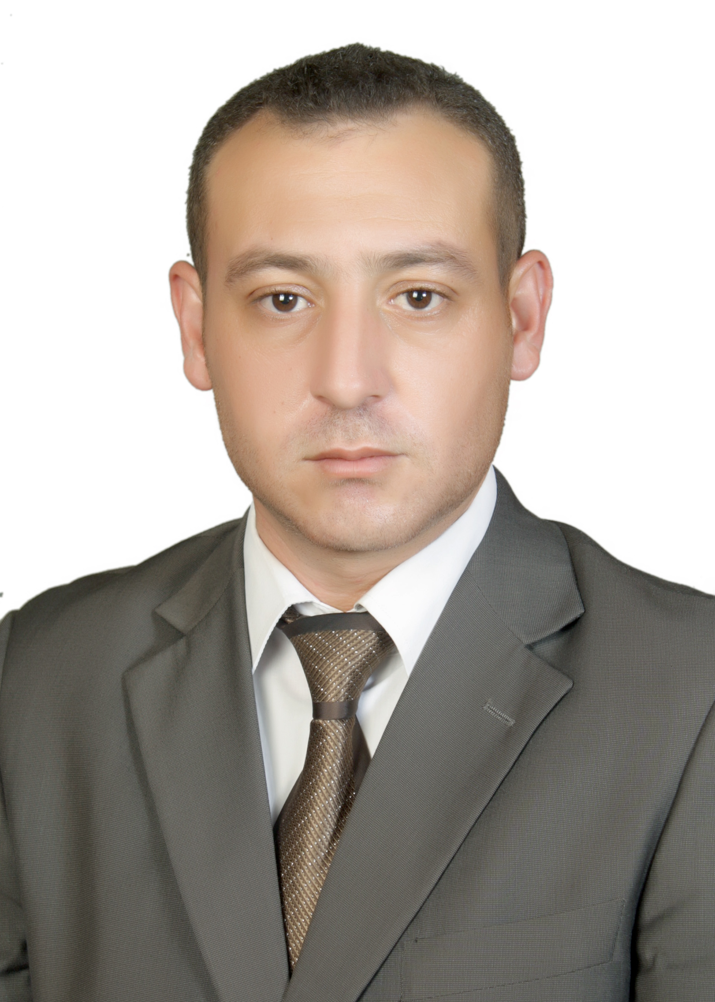

Summary

Hold PhD in computer science\ artificial intelligence and solution of information security. 11 years of Experience as a lecturer. Taught many course such as Artificial Intelligence, algorithms, Database and operating system as well as C++, C#, SQl, visual basic, Data communication and networking, discrete mathematics, introduction to software engineering, introduction to information technology, E-learning, logic design, software project management, computer skills and internet skills. Have many publications in the fields of CS.

Skill Highlights

|  |  |
| --- | --- |
| * Project Leading | * Researching * Programming |

Experience

* **Part Time Lecturer** - 2010 /2011

**Ajloun National University**, Jordan.

* **Full Time** **Lecturer** - 2011 to 2020

**Ajloun National University**, Jordan.

**Full time assistant prof -**2020-2022

* **Part Time Lecturer** - 2012 /2015

**online /university of creative sciences**

Education

**Institution**: International Islamic University Malaysia

**Year**: 2020.

**Degree**: Ph.D., Computer science\ artificial intelligence and solution of information security.

**Thesis**: Speaker Identification Based On Hybrid Feature Extraction Techniques.

**Institution**: Al-Al-Byte University, Jordan

**Year**: 2010

**Degree**: Master in Computer Science

**Thesis**: Speaker Recognition Using Discrete Wavelet Transformation.

**Institution**: Jarash University, Jordan

**Year**: 2005

**Degree**: Bachelor of computer science.

**Project**: Online E-learning System.

**Dr. Feras Eid Dheif Allah Abualadas**

Contact

**Address:**

**Jordan-Jarash .**

**Phone:**

**00962795167595**

**Email:**

Firas4_ads@yahoo.com

Languages

Arabic – Native

English – Very good

Publications

Abualadas, F. E., Zeki, A. M., Al-Ani, M. S., & Messikh, A. E. (2019). Speaker Identification based on Hybrid Feature Extraction Techniques. *International Journal of Advanced Computer Science and Applications (IJACSA)*, *10*(3).‏

AbuAladas, F. E., Zeki, A. M., Al-Ani, M. S., & Messikh, A. E. (2017, November). Speaker identification based on curvlet transform technique. In *2017 International Conference on Computing, Engineering, and Design (ICCED)* (pp. 1-4). IEEE.‏

AbuAladas, F. E., & Zeki, A. M. (2016). Automatic Speaker Recognition System. Journal of Advanced Science and Engineering Research, Vol 6, No 1, 1-8.

AbuAladas, F. E., & Samawi, V. W. (2013, December). Speaker Identification Using Selected Features from DWT. In 2013 International Conference on Advanced Computer Science Applications and Technologies (pp. 114-119). IEEE.‏

**Supervision**

* Supervisor of the graduation project by the king abdullah development fund
* Supervisor of the graduation project for Cs-student
* Supervisor at ACM competition 2015
* Supervisor at CPC competition 2018
* Supervisor at jerash university competition 2014/ 2015
* Supervisor at jerash university competition 2018