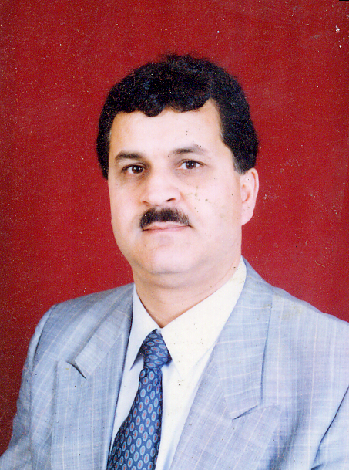 C.V

Prof. Dr. Eng. Mohammad Aref Al-Kadri
Place of birth: Rihan (Damascus) - Syria
Birth date: 22.8.1955
Languages: Arabic and German very good + English, French good

Educational stages:

1961-1973: Primary and secondary school, general secondary education scientific certificate

1973-1978: Architecture study-Damascus university-Bachelor with good rating.

1979-1981: Obligatory military service as an architect.

1982-1987: German language and architecture study in Braunschweig and Hanover-West Germany, Diploma with good rating, in addition to I worked between 1982-1985 at Woldt and Partners in Salzgitter-West Germany.

1988-1992: Dissertation for the doctorate title:
(Arabic architectural heritage as an element of urban development in Syria)
(Arabische Baukultur Als Element Städtebaulicher Entwicklung in Syrien)
Acquired the Doctor grade with very good rating.

Professional and Academic experience:

1993-1996:
Practiced my profession in West Germany, Saudi Arabia, and Syria for designing and supervising of several projects: Public building- traffic planning- contribution of preparing the Master Plan of Damascus.

7.1996- 7.2002: (6 years)
7.1996- 7.1998 Assistant professor, 7.1998-2002Associate professor at Omdurman Islamic University in Sudan for teaching architectural design, working drawing, urban planning, supervisor and coordinator for the 5th year graduates- implementation of several modernized mud buildings.

7.2002 – 7.2007:
Technical advisor and consultant by German Technical Cooperation GTZ in Shibam Urban Development Project (Yemen)- Supervisor of the Shibam Historic Houses Program

Main duties:

- Initiate and carry out an assistance program for home owners in the historic UNESCO mud City of Shibam .
-Assist in establishing institutional and technical capacities.

September 2007:

Dean of the Architecture faculty in ITTIHAD University – Raqqa- Syria

-Lecturer for the subjects: Architectural Design for the 5th, 3rd, second and first year- Renovation of historic buildings for 5th year- Landscape architecture for the 4th year.

-Supervisor of several Projects and head of the commission for the 5th year graduates.

1.2009:
Professor at Al-Wadi International University WIU-Homs –Syria
-Lecturer for the subjects: Architectural Design, executive Design

October 2009:
Professor at Omdurman Islamic University-Republic of Sudan

-Lecturer for the subjects: Architectural Design, Urban planning, executive Design, and Urban sociology.
-Supervisor of 5th year graduates students
-Supervisor of several Post graduates students: Master and PhD

10. 2010 – 10.2013:
Head, Department of Architecture and Planning– Omdurman Islamic University

• 2013-2014:
Head, Department of Postgraduate Studies – Faculty of Engineering Sciences Omdurman Islamic University

2015 - 2019:
Professor and Head, Department of Architecture – Jerash University- Jordan

October 2019:
Professor at Department of Architecture- Jerash University

September 2021:

Head, Department of Architecture – Jerash University- Jordan

Research, scientific conferences, and academic activities:

8.2014
Internal examiner for doctoral dissertation:
Development of a tool to assess the sustainability of major Residential projects-Khartoum- Ayman Khalil Abdul Qadir.

7.2014
Supervision of doctoral thesis:

Application of Sustainability Criteria on Office Building Design in Sudan
Rania Abdel-Rahman.

2.2014
Supervision the research master:
Study of Islamic architecture in Libya in terms of form and function, with a focus on the architecture of mosques
Mekdam Al-Opaidi

5.2013
Supervision of doctoral thesis:
A Sustainable Urban Planning Concept for Omdurman / Sudan
Safaa Ahmed

10.2013:
Visiting Professor at the University of Science Malaysia USM Penang - Housing, Building and Planning School , the visit included a lecture and seminar on sustainability in architecture, planning and discuss with students in Studio Work

10.2013:
International Conference on Sustainable Architecture and Urban Design/Penang
Participate in the workshop Livable Cities emanating from the conference and give a lecture at the opening entitled:
Traditional Arabic Architecture, Functional Capability, Healthy and Sustainability

8.2011
internal examiner for doctoral dissertation:
Making yesterday Hospitals working today
Saad Ahmed Ibrahim.

6.2012
Evaluation of the scientific paper :
Cultural impact on traditional Sudanese human settlement patterns
Walid Abdul Aziz Ali Ahmed, Faculty of Architecture, University of Khartoum
1.2010:
Supervision of doctoral research:
Application of total quality standards in government engineering projects in Sudan
Mohammed Ali Ahmed Jali - Discussion: 5.2013

2011-2013:
Test applicants for government jobs (Architecture graduates) at the Ministry of Urban Planning, commissioned by the management of scientific affairs Omdurman Islamic University.
6.2011
Supervision the research masters:
Illegal Housing expansion in residential neighborhoods and the impact on the environment and urban planning - case study city of Sanaa.
Ali Mohammed Yahya Mazkur

6.2009
Lecture on the restoration of historic houses in the old city of Damascus and the properties of the used building materials - GTZ German Foundation for Technical Cooperation

7.2008
Participate in the workshop: Old city of Damascus urban development project with the German Organization for Technical Cooperation (GTZ).

2007
participate in Conference of Arab and Islamic Cities - Damascus

2004
Participate in the workshop on traditional building materials-Mukalla, Yemen held by General Organization for Preservation Historic Cities in Yemen GOPHCY

2003
Participate in the workshop on historical documentation, capacity building - German Organization for Technical Cooperation (GTZ) – Shibam Urban Development Project - Yemen

1996
Participate in a televised seminar on traditional architecture and display the characteristics of a pilot project to develop in the countryside of Damascus.

1995
Publication of research entitled:
The development of the mud building in Damascus in the Journal of the Arab-Engineer Damascus

1994
Lecture entitled:
Revival of the Building traditions of the Arab architectural heritage
Faculty of Architecture- University of Damascus

1993
Lecture entitled:
History of architecture and cities building in Syria - Institute for the History of cities building Hanover - Institut für Stadt- und baugeschichte-Prof. Meckseper-Hannover Germany

E-mail: kadrimohamad @yahoo.com
Syria- Damascus Tel. 5371005, mob. : 0944550267
Sudan- Khartoum mob.: 00249906172769
Jordan, Jerash mob.: 00962778461964

