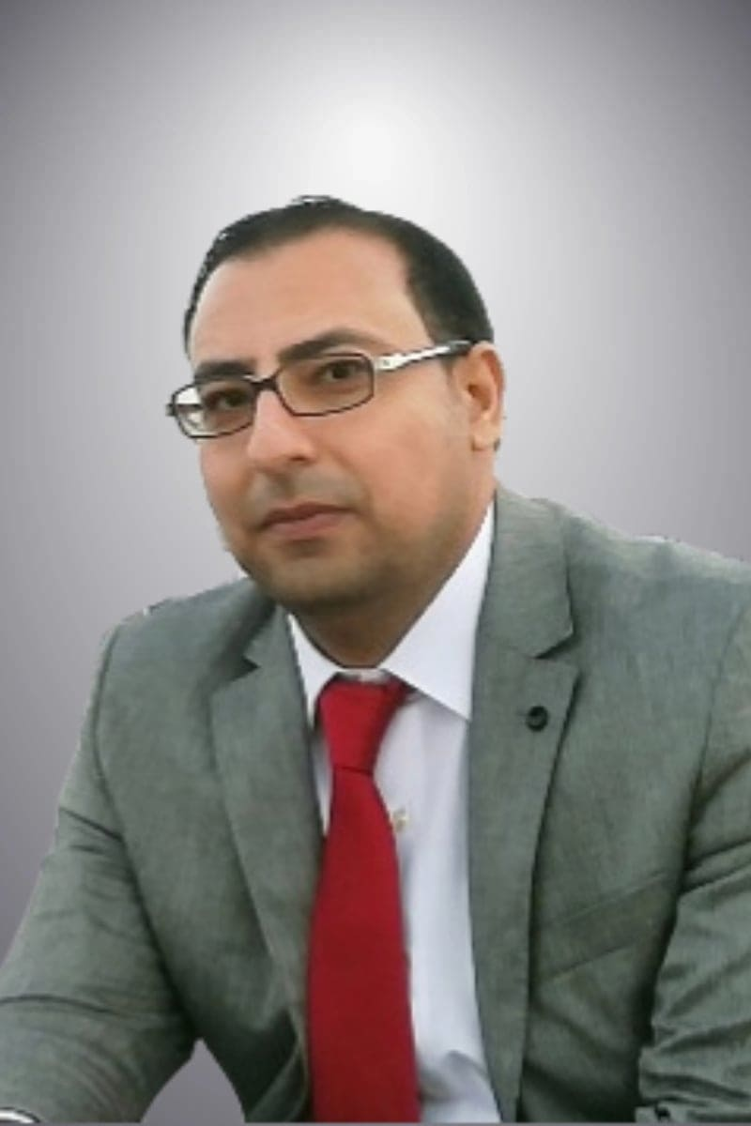
Resume

Dr. Amer Mahmood Rabei
Assistant Professor of Arabic Literature and Criticism
Jerash University, Jerash, Jordan
Email: dr.amer5rabie@yahoo.com
Tel.: +962(0)0777510537

PERSONAL INFORMATION

Full Name: . Amer Mahmood Mohammad Rabei
Nationality: Jordanian
Place/Date of Birth: Ajloun, 3/8/1981
Marital Status: Married
Academic Rank: Assistant Professor
Major: Arabic Literature and Criticism
Affiliation: Department of Arabic Language and Literature, Faculty of Arts, Jerash University, Jordan.

EDUCATION

- High School of scientific from Al-Qabsi for Boys, Class 2001AD.
- Bachelor Degree of Arabic Language and Literature from Jerash University, Class 2006 AD.
- Master Degree of Arabic Language and Literature from Jerash University, Class 2009 AD.
- Doctor of Philosophy in Arabic Literature and Criticism from Yarmouk University, Class 2013AD.
- Doctoral dissertation (Intertextuality in the poetry of Mehyar Al-Dailami),from Yarmouk University.

RELATED EXPERIENCES

- Student Affairs Administrator, 2006- 2008AD.
- President of the Student Arrivals Division at Jerash University, 2008AD.
- President of the Graduate Students Division at Jerash University, 2007 AD.
- Teacher Arabic( grammar) at the King Abdullah II Institute for to prepare, qualify and train advocates (Programmer for the Rehabilitation of Imams and Muezzins IV /Second Constituent Level), 2014AD.
- A Faculty member of Jerash University from 2008 AD to now.

PUBLICATIONS Papers:
- The phenomenon of smoking and its semantic dimensions in Nizar Qabbani's poetry.
- The wife in the poetry of the Prince of Tramps.
- The technical of Argumentation in Al-Shqandi letter in (the graces of Al - Andalus) rhetorical means and arguments based on the structure of reality, Al-Shaer Magazine, Tunisia.
- Autobiography as type of written.
- The introductory structure - Al-Asma'i as a model.
- A poem hkdha tahadath Prometheus, by the Tunisian poet Nasr Sami, in light of the aesthetic criticism method.
- intertextual in the poetry of Abu Ishaq Al Libeiri (d.460 AH), the ancient Arabic poetry and the hadith of the Prophet two models.

RELEVANT COMMITTEES

- Member of the Quality and Accreditation at Jerash University, 2008AD.
- Member of the Coordination of Graduates Yearbook University of Jerash, 2008.
- Chair of the Committee the Social and Cultural Committee at the Faculty of Arts, Jerash University, 2013-2015.
- Member of the Seventeenth Conference (Literary Heritage in Andalusia - A New Reading) 2014 AD, Jerash University.
- Member of the Sixteenth Conference (Literature of the successive ages in tradition and innovation - a new reading and evaluation), 2013 AD.
- Member of the International Symposium (Biography at the crossroads of literary races between East and West) 2018, Tunisia.
- Member of the conference (Contemporary Education and Citizenship) 2018
- Member of the conference (language between past, present and future), Ain Shams University, 2016.
- Member of the Nineteenth Critical Conference (Renewal Movements in Modern Arabic Literature and Its Criticism) 2016, Jerash University.
- Member of the Student Parents Council at Baraem Islamic Academy School.
- Member of the Aqraba Charitable Society.
- Member and Supporter of Raymon Sports Club.

COURSES TAUGHT

Bachelor:

- Grammar (1).
- jahili poetr.
- ancient prose.
- The art of writing and expression.
- Communication Skills in the Arabic Language(101).
- Communication Skills in the Arabic Language(102).
- Basics of the Arabic language.
- Abbasid poetry (1).
- Abbasid poetry (2).
- alghazl aleudhriu.
- Rhetoric.
- ancient criticism.
- Islamic and Umayyad poetry.
Master:
- Seminar in ancient literature.
- Seminar in Modern Poetry.
- Seminar in ancient criticism.

Courses:

- Computer and Printing Course.
- The fifteenth training workshop for faculty members at Jerash University.
- Training of Trainers TOT, 2018AD.
- Creating motivation and motivation of students. 2017
- Academic guidance and counseling skills,2016.
- Creativity in problem solving and decision making, 2015.

Languages:

- Arabic: Mother language.
- English: Read, write and speak (good) and have a TOEFL.

