Curriculum Vitae
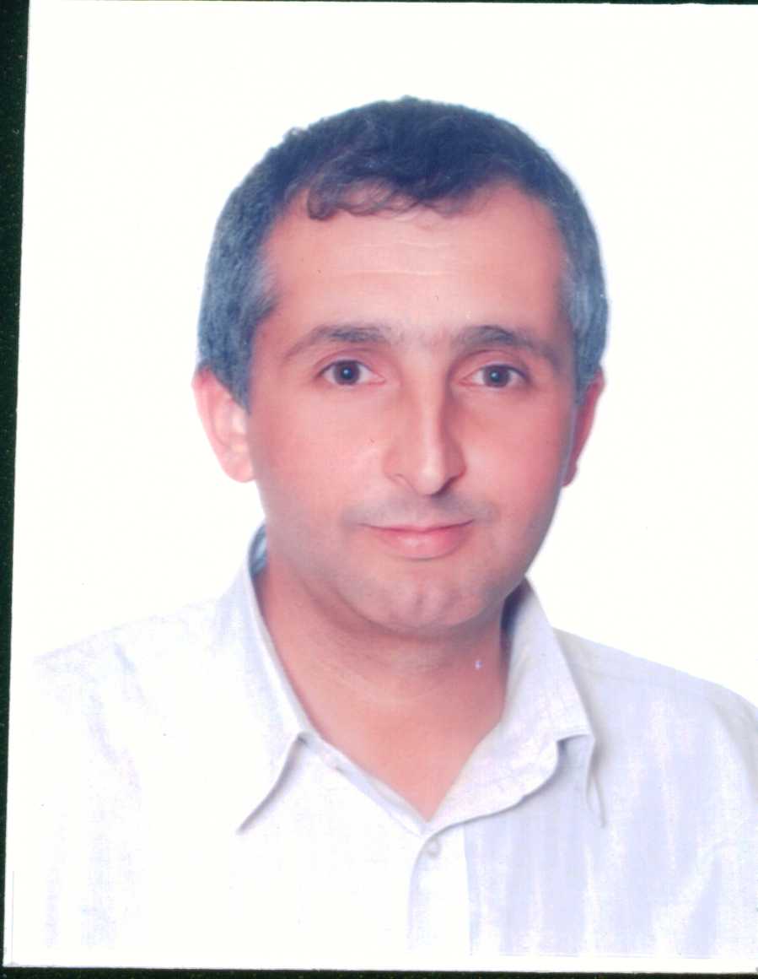
Dr. Mohammad Husein Brake, PhD.

PERSONALS DETAILS:
Nationality | Jordanian
Place and Date of Birth | 26th August 1972 Rhaba - Jordan
Martial Status | Married
E-mail | mohammadbrake@hotmail.com
Telephone –Mobile | +962 (7) 91984809

EDUCATION

PhD January 2004 | Biotechnology
Specialization | Plant Biotechnology
Thesis | Characterization of Red Chicory grown in Veneto by means of molecular fingerprinting and genetic mapping.
University and place | Padova University, Italy
BSc. June 1996 | Biological Science - Yarmouk University, Jordan
Languages | Arabic: Mother Language  English: Very good  Italian: Very good

Current occupation
Associate Professor, Biology Department – Jerash University – Jordan
PREVIOUS EMPLOYMENT:
5/2017-Present: associate professor, Biology Department – Jerash University – Jordan
2007- 5/2017: Assistant Professor, Biology Department – Jerash University – Jordan
2009-2012: Part-Time researcher, Royal Scientific Society
2008-2009: FAO Consultant, Establishment of a National Information Sharing Mechanism on the Global Plan of Action implementation in Yemen and the preparation of a Country Report on the State of the Plant Genetic resources for Food and Agriculture (PGRFA),
2009-2010: National FAO Consultant, Strengthening capacities towards the establishment of a regional platform for the detection of genetically modified organisms
2005-2007: Researcher at Biotechnology unit, National Agricultural Research Centre (NARC).
2010-2012: Head of Science department, Jerash University.
2012-2013: Acting Dean of Scientific Research and Graduate Studies, Jerash University.
2014-2017: Team member for "Development of an Interdisciplinary Programme in Climate Change and Sustainability Policy" project.
2017: Evaluator of the outstanding researcher award in the agricultural and veterinary sciences sector/ Scientific Research Fund- Ministry of higher Education and Scientific Research.
2018: National consultant, development of 5 project profiles in the field of sustainable food and agriculture, Ministry of Environment.
13-30/12/2019: FAO Consultant, Translation of "PREPARATION OF COUNTRY REPORTS FOR THE THIRD REPORT ON THE STATE OF THE WORLD’S PLANT GENETIC RESOURCES FOR FOOD AND AGRICULTURE" document to Arabic language.
14/10-20/12/2020 Technical expert for the preparation of reports for The Third Report on the State of the World’s Plant Genetic Resources for Food and Agriculture
Awards
Analysis of apomixis in Hypericum Perforatum L. combining molecular markers and flow cytometry. ARZENTON F., BRAKE M., SGORBATI. S., VAROTTO S.
Proceedings of the XLV Italian Society of Agricultural Genetics - SIGA Annual Congress, Salsomaggiore Terme, Italy - 26/29 September, 2001
Funded Proects
Development of Salinity Tolerant Tomato Genotypes Using Molecular Marker Assisted Selection, Scientific research Fund. 2010-2012
Commercial production of Taq DNA polymerase, Support to Research, Technological Development and Innovation in Jordan (SRTD I), Higher Council for Science and Technology.2008-2009
Fraud detection in olive oil using molecular techniques, Support to Research, Technological Development and Innovation in Jordan (SRTD II), Higher Council for Science and Technology.2014-20016
Training courses as trainee
4-8/12/2005, Mutation detection by using molecular techniques, Damascus
15-19/5/2006, Introduction to biosafety for the environmental release of GMO crops
ICGEB, Italy
Training courses as trainer
March and April 2009, an introduction for polymerase chain reaction technique, Al Balga University, Al zarqa.
May 2009, an introduction for polymerase chain reaction technique, Al Balga University, Al zarga.
Conferences, SEMINARS, and workshops
- February 2006, Biotechnology in Agriculture, Amman, (presented paper)
- 1-10/3/2007 Workshop in phylogentic studies, California University, (attendance)
- 22-24/5/2007, Third Seminar on Biotechnology and its Applications in Arab Agricultural Investment – Amman, Jordan, Scientific and organizing committee
- Mohammad S. Jawarneh, Mohammad H. Brake, Riad Muhidat, Hussein M Migdadi, Jamil N. Lahham, Ahmad Ali El-Oqlah (10-12.9.2012), Characterization of Quercus Species Distributed in Jordan Using Molecular Markers. International Conference on Applied Life Sciences. Konya, Turkey
- Mohammad Brake, Hussein M. Migdadi, Monther sadder, Lana Gadomi, Muien Qaryouti, Mahmoud Al-Khatib, Ahmad Ali El-Oqlah (10-14.11.2013), Microsatellite assessment of genetic diversity among Jordanian tomato
(Solanum lycopersicum L.) Landrace. 2013, The International Plant Breeding. Antalya, Turkey
- Mohammad Brake (29/6-1/7.2015), Profiling salinity responsive genes for local Jordanian tomato landraces under salinity stress. 2015, Plant Abiotic stress III. Vienna, Austria
- Mohammad Brake (5-6.7.2018), Influence of Storage Temperature and Duration of Tomato Leaf Samples on Proline Content. 2018, Plant Abiotic stress V. Vienna, Austria
- Mohammad Brake (15-17.10.2018), Assessment of Genetic Diversity among Jordanian tomato (Solanum lycopersicum L.) landraces using ISSR molecular markers. 2018, Eighth Scientific Agricultural Conference. Mutah University, Karak - Jordan
Scientific visit
8-25/10/2007, the application of biotechnology technique for food quality, Parma University Italy
Teaching Experince
At Jerash University:
- General Biology (101)
- Genetics (345)
- Biotechnology (453)
- Molecular Biology (456)
- Human Genetics (302448)
- Biodiversity (447)
- Economic Botany (222)
PUBLICATIONS:

Papers
- Haddad.N.J, Brake M., Migdadi H. de Merinda, J. (2008). First detection of honey bee viruses in Jordan by RT-PCR. Jordan Journal of Agricultural Sciences, 4 (3): 242-247
- Al Awamleh H.S, Hassawi D.S, Migdadi H.M, Brake, M . (2009). Molecular Characterization of Pomegranate (Punica granatum L.) Landraces Grown in Jordan Using Amplified Fragment Length Polymorphism (AFLP) Markers. Biotechnology, 8 (3): 316-322
- Mansour. M, Hassawi. D*, Migdadi. H, and Brake. M. (2011). Fingerprinting Date Palm Genotypes (Phoenix dactylifera L.) Using Inter Simple Sequence Repeat (ISSR) Markers. Journal of Genetic and Breeding, 63: 17-22
- Mahmoud AL-Khatib, Mohammad Brake, Muien Qaryouti, Khalaf Alhussaen and Hussein Migdadi (2012). Response of Jordanian tomato land races to Fusarium oxysporum f.sp. lycopersici. Asian journal of Plant Pathology, 6 (3): 75-80
- Mohammad S. Jawarneh, Mohammad H. Brake, Riad Muhidat, Hussein M. Migdadi, Jamil N. Lahham, Ahmad Ali El-Oqlah1 (2013). Characterization of Quercus species distributed in Jordan using morphological and molecular markers. African Journal of Biotechnology, 12(12): 1326-1334
- Mohammad H Brake, Hussein M. migdadi, Moath Al-Gharaibeh, Salam Ayoub, Nizar Haddad, Ahmad El Oqlah (2014). Characterization of Jordanian olive cultivars (Olea europaea L)using RAPD and ISSR molecular markers. Scientia Horticulturae, 176(11): 282-289
- Nizar Jamal Haddad , Ahmed Batainh, Deepti Saini, Osama Migdadi, Mohamed Aiyaz, Rushiraj Manchiganti, Venkatesh Krishnamurthy, Banan Al-Shagour, Mohammad Brake, Lelania Bourgeois, Lilia De Guzman, Thomas Rinderer, Zayed Mahoud Hamour (2016). Evaluation of Apis mellifera syriacaLevant region honeybee conservation using comparative genome hybridization. Genetica, 144(3):279-287
Doi:10.​1007/​s10709-016-9897-y
- Mohammad H. Brake, Hassan R. Hamasha, Hussein M. Migdadi, Ashraf O. Khashroum, Moath Al-Gharaibeh, Muien M Qaryouti and Mahmoud T. AL-KHatib. (2017). Influence of storage temperature and duration of Tomato leaves samples on proline content. European Scientific Journal, 13(6): 116-123
Doi: 10.19044/esj.2017.v13n6p116
- Riyadh Muhaidat, Mohammad H. Brake, Mazhar Al Zoubi, Robert I. Colautti, Amjad Al-Nasser, Muheeb Awawdeh, Khalid Al-Batayneh, Wesam Al Khateeb, Athena D. McKown, Jamil Lahham and Ahmad El-Oqlah. (2018). Integrating morphological characters, molecular markers, and distribution patterns to assess the identity of Blepharis species from Jordan. Botanical Studies, 59:18.
- N. Haddad, H. Migdadi, R. Al-Atiyat, K. Jawasreh, S. Awabdeh, W. Obeidat, R. AlOmari, M. Aldamra, H. Ababneh, M.J. Tabbaa, M. Brake and M. Farooq. (2020). Whole Genome Resequencing of Jordanian Awassi Rams (Ovis aries) Using Hiseq Sequencing Technology: The First Step Towards Sheep Genomic Selection. Genetics and Molecular Research, 19(2).
DOI http://dx.doi.org/10.4238/gmr18577
- Mohammad H. Brake, Moath A. Al-Gharaibeh, Hassan R. Hamasha, Nuha S. Al Sakarneh, Ibrahim A. Alshomali, Hussein M. Migdadi, Muien M. Qaryouti, Nizar J. Haddad. (2021). Assessment of genetic variability among Jordanian tomato landrace using inter-simple sequence repeats markers. Jordan Journal of Biological Sciences, 14(2): accepted.
- Haddad, N., Migdadi, H., Brake, M., Ayoub, S., Obeidat, W., Abusini, Y., Aburumman, A., Al-Shagour, B., AlAnasweh, E., and Sadder, M. (2020). Complete chloroplast genome sequence of historical olive (Olea europaea subsp. europaea) cultivar Mehras, in Jordan. Mitochondrial DNA Part B: Resources (submitted).

