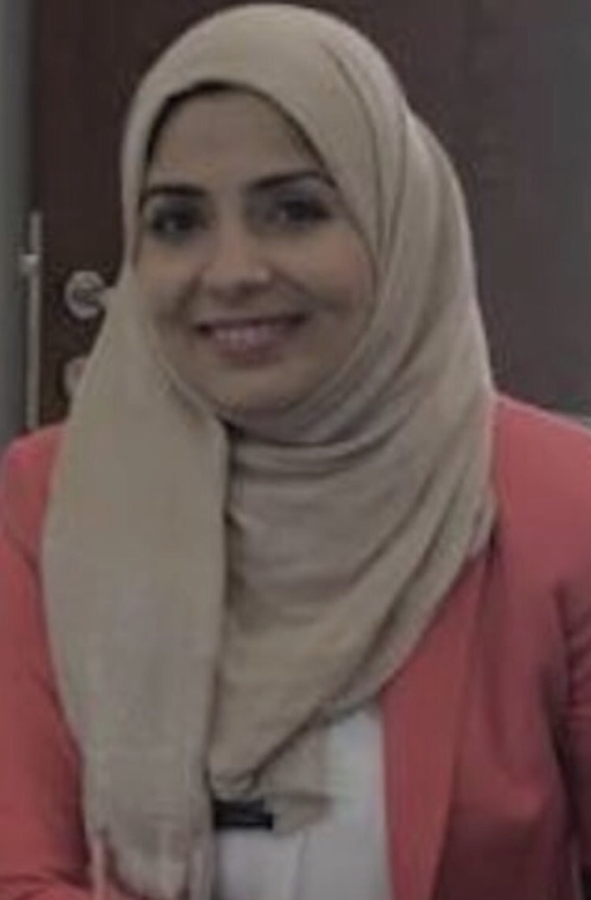
LAILA MOHAMMED DAMRAH
Assistant professor - Special Education

Nationality: Jordanian Marital status: Single
Mobile: (JO) +962792001696
E-mail: Ldamrah@gmail.com
https://scholar.google.com/citations?hl=en&user=-y6RT_kAAAAJ
https://orcid.org/0000-0001-5860-2432
https://www.linkedin.com/in/laila-damrah-1a072b7b/

Educational Qualifications
Degree | University | Specialization | Year
M.A | University of Jordan | Human Rights | 2023
PhD | University of Jordan | Special Education | 2011
Dissertation @ Theses
Damrah, L. (2022). Enabling policies for persons with disabilities in light of sustainable development goals-case study of Jordan [Unpublished Master Theses]. University of Jordan.
Damrah, L. (2011). Level of empowerment and support among families of children with disabilities in Jordan and proposed model for empowerment and support [Unpublished doctoral dissertation]. University of Jordan.
University Teaching & Work Experience History
- Assistant Professor, Faculty of Educational Sciences, Jerash University (2024).
- Head of the Department of Special Education at Jerash University (2024).
- Assistant professor, faculty of Educational Studies, Arab Open University-Jordan, 2013 – Jan 2024.
- Coordinator of Learning Disabilities Program at the University, 2019-2022.
- Head of "Center for Learning Disabilities (LD)" - Arab Open University, 2020 – 2024.
- Assistant professor, King bin Abdul-Aziz University, Jeddah, Kingdom of Saudi Arabia, 2011- 2012.
- Part - time Lecturer, University of Jordan, 2005.
- Research and teaching assistant at the University of Jordan, 2004 – 2011.
- Member of committees in the Department and university.
Committee’s member
1- Grant committee for distinguished and financially indeed students in the university in Jordan (2019 – 2022)
2- Exam committee in the Arab Open University – Jordan (2021 - 2022).
- Course equivalence committee in the Arab Open University – Jordan (2021 - 2022).
- Council of Arab Open University – Jordan (2021 - 2022).
- Branch Strategic Plan Committee in the Arab Open University – Jordan (2021 - 2022).
- Quality assurance committee in the Arab Open University – Jordan (2021 - 2022).
Research and Publications
Researchs
- Damrah, L. (2023). A bibliometric and content analysis of learning disabilities research published in scientific journals issued by Jordanian universities during the years (2020-2022). The Educational Journal of the Faculty of Education at Suhag University, 110(1), 40 - 68. DOI: 10.21608/EDUSOHAG.2023.305008.
- Damrah, L. (2023). Difficulties facing teachers in teaching Mathematics to students with learning disabilities in light of Corona pandemic and proposed solutions from the teachers' point of view, Journal of the Association of Arab Universities for Research of Higher Education, 43(1), 244 - 256. DOI: 10.36024/1248-043-001-016.
- Al-husban. N; AlMashaleh, M; Damrah, L. (2022). Exploring first and fourth year university student’s level of critical thinking skills at Arab Open University- Jordan. Curriculum and Teaching. Australian Catholic University, 37(2), 55-72. DOI: https://doi.org/10.7459/ct/37.2.05
- Damrah, L. (2022). The Role of Jordanian Television Channels in Raising Awareness of Children’s Learning Disabilities. IUG Journal of Educational and Psychology Sciences. 30(4), 532-556. https://doi.org/10.33976/IUGJEPS.30.5/2022/25.
- Damrah, L. (2021). Self-Assertiveness and the relationship with Academic Self-Efficacy and Student Engagement of Jordanian Students: A Descriptive, Correlational Study. International Journal of Pedagogical Innovations, 9(1), 1-7. DOI: https://dx-doi.org/10.12785/ijpi/090101
- Damrah, L; Smadi, J. (2016). The degree of contribution of the change in family demands, family sources and family perceptions in explaining the variance in both family empowerment and family support. Dirasat journal-Educational Sciences, 43(1), 1-22. https://archives.ju.edu.jo/index.php/edu/article/view/4311
- Damrah, L; Smadi, J. (2016). Level of Support among Families of Children with Disabilities in Jordan. Dirasat journal-Educational Sciences, 43(Supplement-3), 1150-1137. https://archives.ju.edu.jo/index.php/edu/article/view/6485.
- Damrah, L. (2015). The Level of using the Practices based on the families of disabled children by Caregivers in Jordan in Light of Various Variables. Dirasat journal-Educational Sciences, 42(3), 1179-1202. https://archives.ju.edu.jo/index.php/edu/article/view/4517/4834
- Damrah, L. (2015). The Level of Empowerment among Families of Children with Disabilities in Jordan. Special Education & rehabilitation, 2(7), 1-29. Doi: 10.21608/SERO.2015.92159
Research accepted for publication
- Damrah, L. (2023). The Reality of Using Artificial Intelligence Applications by Teachers of Learning Disabilities in Education. Journal of Educational and learning (Edulearn).
Research under review.
- Damrah, L; Almada, B. (2023). Enabling policies for persons with disabilities in light of sustainable development goals-case study of Jordan. European Journal of Psychology of Education (EUPE),
Books
- Kasawneh, M. Alkawaldeh, M. Damrah, L. Abo Hawash. R. (2015). Academic Learning Disabilities. Dar Al-Fikr, Amman: Jordan. https://www.daralfiker.com/node/7429
- Kasawneh, M. Alhersh, J. Damrah, L. AlKawaledeh, M. (2014). Introduction to learning disabilities, Dar Al-Fikr, Amman: Jordan. https://www.daralfiker.com/node/7159.
Translation of the Books.
- Katie W; Molly C; Martha, W; Colleen, M; Waisman C. (2013). Fostering Self-Determination among Children and Youth with Disabilities. Dar Wael. Amman, Jordan.
Conferences, Training, and workshops
Conferences.
- Damrah, L. (2023, July 3-6). Digital learning competencies among female students of the Learning Disabilities Department at the Arab Open University-Jordan. 15 International Conferences on Education and New Learning Technologies, Palma (Spain), the International Academy of Technology, Education and Development (IATED), Doi. 10.21125/edulearn.2023.0726.
- Damrah, L. (2023, Jan 23 -25). The Reality of education sector in Jordan considering the sustainable development goals. INTCESS 2023- 10th International Conference on Education & Education of Social Sciences, (Istanbul) Turkey. https://doi.org/10.51508/intcess.202310.
- Damrah, L. (2016, Nov 29 – 30). Institutionalizations and Enhancement of Services Provided to Children at Nurseries. Preparing the Arab Educator professionally and cognitively (Was participation in the role of institutions AGFUND in enhancing teacher training programs in early childhood), the Dead Sea (Jordan).
- Towards sustainability in early childhood development in the twenty-first century 24-27 March 2014, Amman.
- Scientific Research in the Arab Countries: Challenges and Solutions, March 18-19, 2014, Dead Sea – Jordan.
- The 13th Washington Group Meeting on Disability Statistics, October 29-31, 2013, Amman.
- Tempus 2007 conference - University of Jordan – Amman.
- The Arab Special Education Conference (Reality and Hope) 26-27 4- 2005, under the patronage of Her Majesty Queen Rania Al Abdullah. The University of Jordan – Amman.
Training and workshops.
- "Applications of artificial intelligence in education". An-Najah University/ via Zoom, on 1/ 5/ 2023.
- An advanced course on student success according to the Multi-Tiered System of Supports (MTSS), via the Zoom application, on 9/2/2023. For seven hours.
- “Train The Trainer”, held in American Institute of Professional Studies, from 10 – 13 July 2017. For 40 training hours.
- Training Program: Measurement and Diagnosis of Autism Disorder". 2016, 40 training hours, through the Jordanian Center of Excellence in Special Education in cooperation with the Jordanian Institute for Community Rehabilitation at Mutah University.
- Raising the level of services provided to children in nurseries and institutionalizing them", which was held at the Arab Open University in cooperation with the National Council for Family Affairs and (AGFUND) the Arab Gulf Program for Development.
- A workshop entitled “Applications of brain research in the development of a pre-school child’s learning”, John Joseph Amman, March 24-27, 2014.
- The effects of the media and the Internet on children, d. Eric Sigman Amman March 24-27, 2014.
- Professional Trainer (TOT): Understanding in Practice” – from 11- 16 April 2013 and completed coursework which represents a total of 50 hours. From (Institute Leadership & Management (ILM)) - England.
- Workshop on "Quality Assurance and Institutional Evaluation" (2/5/2012) at King Abdelaziz University.
- Training entitled Academic Programs: How do they depend? According to the standards of the National Commission for Academic Accreditation and Assessment (18/4/2012), King Abel-Aziz University.
- Training on “Strategy for Dealing with Scientific Research Data” (18/3/2012) King Abdelaziz University.
- Workshop (Achievement file - Portfolio) (11/3/2012) King Abdelaziz University.
- A training program to ensure and control the quality of teaching and learning processes (31/12/2011-7/2/2012) King Abdelaziz University.
Other Professional Experience
Courses I taught.
- Introduction to Special Education
- Curricula and teaching methods in special education
- Physical and health disabilities
- Awareness of the disability community
- Rehabilitation of Special Needs
- Early Intervention
- Assessment and diagnoses of learning disabilities
- Language and Communication Disorders
- Teaching methods for students with learning disabilities
10- Behavior modification
11- Working with families of individuals with special needs
12- Developmental Learning disabilities
13- Learning disabilities and academic educational programs
14- Integrating people with special needs in regular schools
15- Practicum (2) in the field of learning disabilities
16- Self-learning skills
17- Psychology
Professional Affiliations and Memberships
- A member of the Jordanian Association of Translators and Applied Linguists
Research Interests
- Inclusive education for children with disabilities.
- Needs and services for families of children with disabilities.
- Rights of people with special needs.
- Family Empowerment.

