year

## Summary

A bright, ambitious, highly motivated and result oriented professional looking for a challenging position in a dynamic and progressive Institution offering work opportunities for skill enhancement, further development, technological advancement and career growth. I am definitely going to be an asset for your organization/Institution and making a significant and valuable contribution as Enthusiastic Lecturer who has earned trust and respect from students, colleagues and administration for 16+ years.

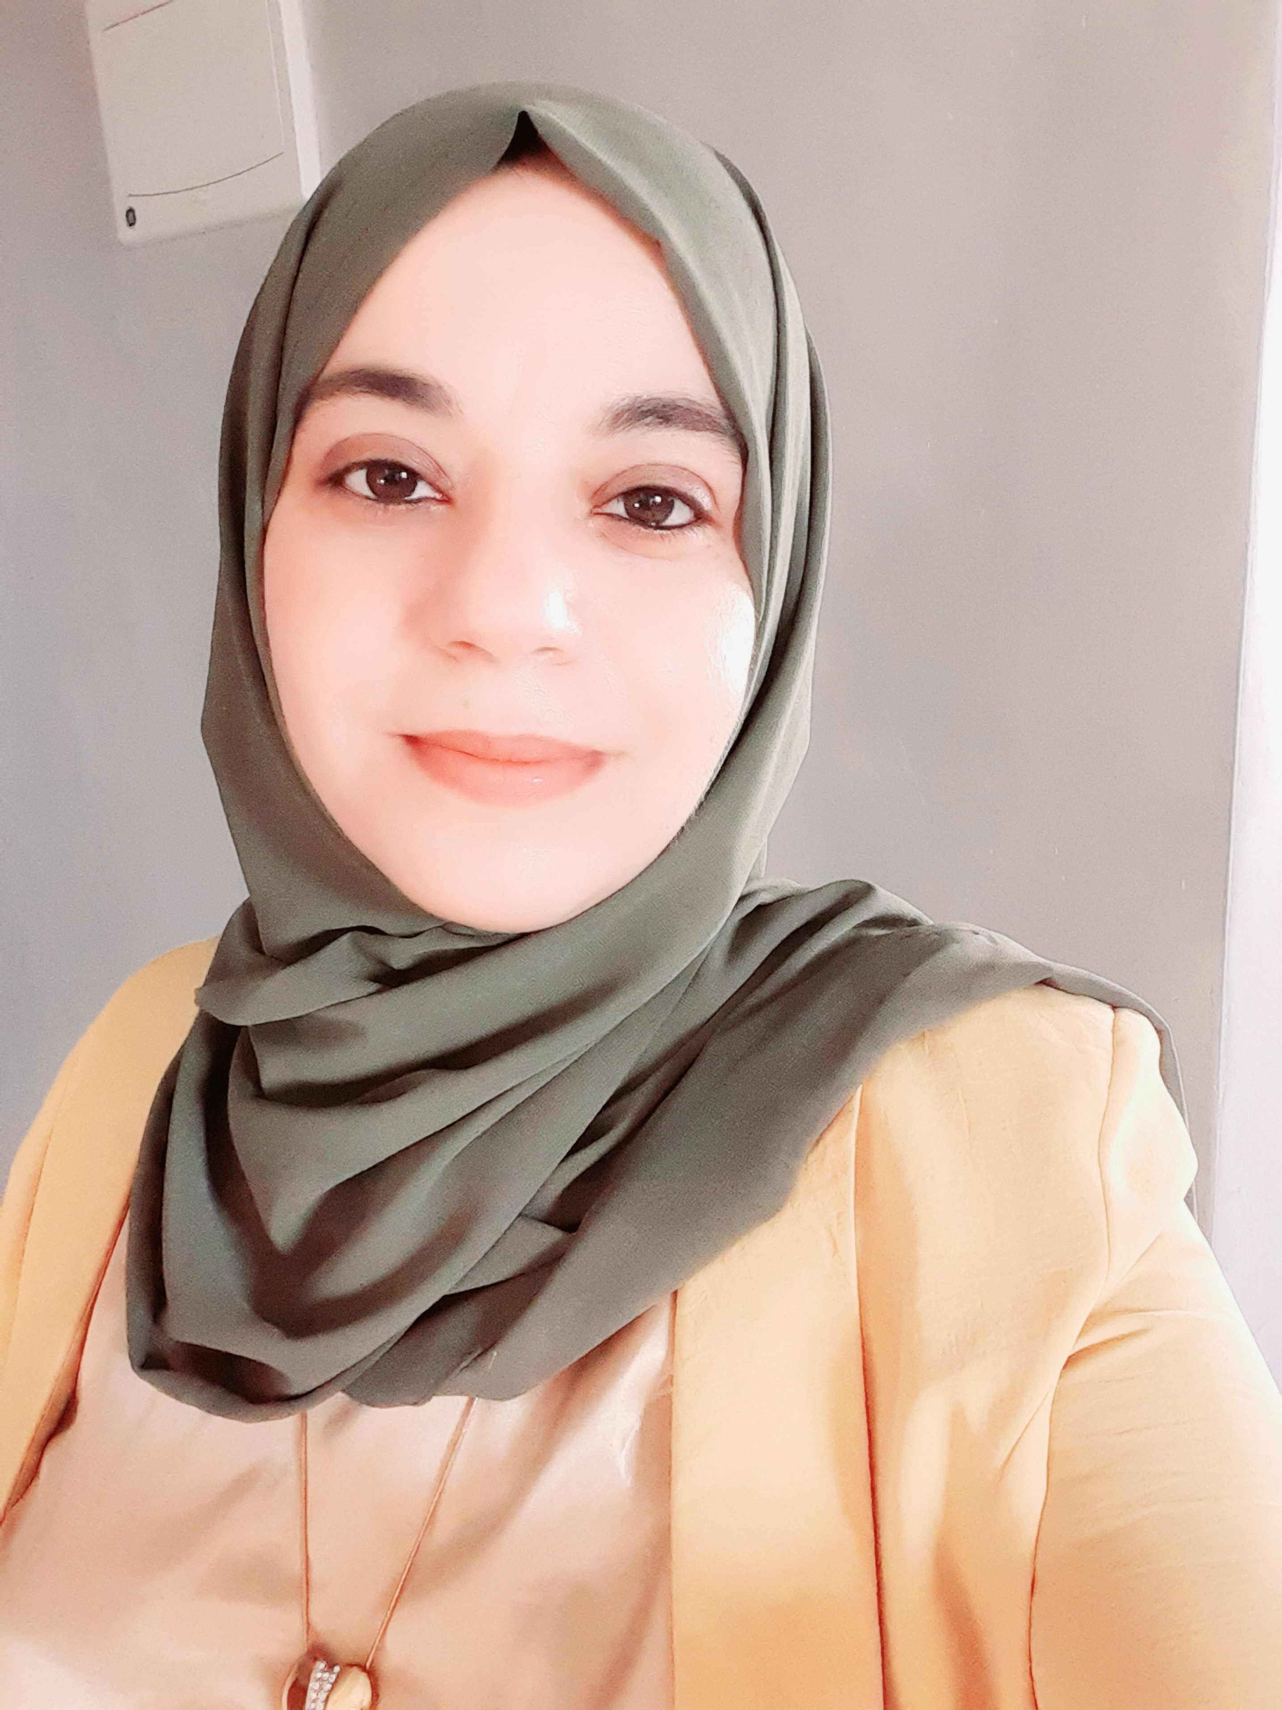

+962 (77) 9-098-767

d.albalawneh@jpu.edu.jo

[da-ad-albalawneh-8a7303157](https://www.linkedin.com/in/da-ad-albalawneh-8a7303157)

Da'ad Albalawneh

## Qualifications

**Ph.D. in Computer Science /Artificial Intelligence,** Excellent rate – 08/2018 to 07/2023

Faculty of Informatics and Computing, Universiti Sultan Zainal Abidin (UNISZA), Malaysia.

**MSc in Computer Information Systems,** 3.32/4 rate– 02/2007 to 6/2010

College of graduate studies, Jordan University.

**BSc in Computer Information Systems,** 3.62/4 rate – 09/2002 to 6/2006

Prince Abdullah bin Ghazi for science and Information Technology College, AL Balqa Applied University.

**General Secondary Education** with Average (90.4), Scientific Stream, Jordan Ministry of Education.

## Experiences

1. **Assistant Professor, Faculty of Computer Science and Information Technology, Jerash University, Jerash, Jordan.** [**https://orcid.org/0000-0002-8412-6350?lang=en**](https://orcid.org/0000-0002-8412-6350?lang=en)
2. **Lecturer**, **Computer Science** – 10/2010 to 8/2017

**University of Hail, KSA.**

**Administrative Responsibilities**

* **A member of the Organizing Committee for the International Conference on Recent Advances in Computer Systems (RACS-2015), Hail, Saudi Arabia, from 30th November – 1st December 2015, with the following duties:**
* Organizing many workshops and discussion sessions for motivating students and faculty members to participate in the conference.
* Preparation of announcements, students' registrations, monitoring participation progress, evaluating students, processing final submissions, and answering questions from students and faculty.
* Preparation of a report on all departmental activities related to the conference.
* The preparation of a comprehensive guidebook for all participants to use as a source of information.
* **A member of the Exam Committee with the following duties:**
* Preparing detailed and accurate minutes of all Committee meetings after taking notes.
* Modifying and preparing forms required for collecting relevant information during an examination.
* The creation and updating of the Examination website.
* Assisting the coordinator in supervising all examination sessions.
* Providing assistance with preparations for smooth examinations, including proctor assignment, exam paper receipt and submission, supervision of exam hall preparations, and handling excuses for absent students.
* Ensuring the availability of proctors and rooms on exam day.
* Managing conflict situations on exam day and reporting them to the CSSE coordinator and committee coordinator.
* Inviting EC members to take part in exam sessions and assigning their duties.
* Collecting and verifying the records of absent students from the proctors.
* Collecting excuses from students for exam absence.
* Preparing a detailed exam report after the exam and submitting it to the EC coordinator.
* Preparing a handbook in cooperation with the coordinator to serve as a guideline for exam committee roles and responsibilities.
* **Computer Science Coordinator of Quality Assurance Unit with the following duties:**
* Working on different strategies regarding the implementation of QA standards at the university.
* Gathering the required information and proposing, designing, and streamlining these requirements with the university’s existing infrastructure.
* Working on Self Study Report and providing an independent opinion.
* Performing exam paper evaluation in the first phase (sample evaluations).
* Supervision on the exam paper evaluation procedure for CS courses.
* Supervision on course, program and graduation evaluation survey process under QA unit.
* Supervision and distributing the task of course evaluation statistics based on the survey results.
* Supervision on the task of ILO’s evaluation for various courses.
* Supervision and organizing the process of gathering, calculating, and collecting evidences regarding KPI’s under different standards.
* **Assistant for Student Activities Committee with the following duties:**

preparing students for the participation in Department/University Level activities including:

* Activities under Student Club.
* Activity preparations for National Day Celebrations.
* Arranging the Computer Day Event.
* Managing and organizing departmental exhibitions.
* Assisting in the preparations and publishing of CCSE Magazine.
* Participating in the “International Day of people with Disability” event.
* **A member of the Scientific Research Committee with the following duties:**
* Creation of Scientific committee website.
* Announcing for access to E-Library.
* Announcing for workshops.
* Collecting Faculty Research Statistics (Publications etc.).
* Gathering Faculty interest based on their specializations.
* Forming Research Groups to carry out research in respective areas.
* Conducting Meetings with Deanship of Scientific Research at UoH in order to promote the research activities in department.
* Managing workshops in CCSE, for scientific research proposal writing in collaboration with the Deanship of Scientific Research at UoH.
* Motivating Students for research through the participation in faculty competitions.
* **Coordinator for the Public Relations Committee.**
* **Examiner for the evaluation of Co-operative work by the students.**
* **Advisor for many students for Co-operative training program.**
* **A member in the College Committee for the evaluation of Graduation Senior Projects.**
* **Supervisor for Graduation Senior Projects.**
* **A member in the Schedule Preparation Committee.**
* **A member in the Graduation Ceremony Organizing Committee.**
* **A member in the Student Advising Committee.**
* **Internal Auditor in QA Unit.**
* **A member in the Senior Project Committee.**

**Academic Responsibilities:**

* **Offering services as lecturer in College of Computer Science and Software Engineering.**
* **Course coordinator for many courses such as Advanced Database Systems, Computer Networks, Data and Computer Communication, Computer Graphics and Data Structures.**
* **As course coordinator, major tasks performed were:**
* Demonstrating appropriate use of current technology in the preparation, creation and delivery of instruction.
* Acquiring, maintaining and applying knowledge of current instructional methodologies and materials.
* Planning and designing the course plan, curriculum, lecture contents, assessments, exams, lab materials and supplementary texts for the taught courses.
* Scheduling regular meetings with co-instructors for course discussions.
* Responsible for the preparation of:

1. Course Folder
2. Course Specifications as per the requirements of the Quality Assurance committee
3. Course Reports at the end of the semester
4. Course Specifications Review Reports (CSRR)

* Advising and counseling students in regard to their academic concerns and career goals.
* Advising Co-op Students with respect to their training places.
* Providing out-of-class academic assistance to students who need/or request it.

1. **High School Teacher, Computer Science** – 08/2006 to 10/2010

**Jordan Ministry of Education, Jordan**

1. Planning and preparing lessons.
2. Engaging students in classroom activities.
3. Developing new teaching materials based on research.
4. Developing new teaching methods and implementing them.
5. Assessing students' work and marking their performance.
6. Organizing assessments and overseeing exams.

## Teaching Courses

**During my service, I have taught the following courses:**

* Cloud Infrastructure and Services
* Artificial Intelligence
* Database Systems
* Data Structures
* Distributed Databases
* Advanced Database Systems
* Computer Networks
* Data Security
* Mobile Applications Development
* Data and Computer Communications
* Software Engineering
* Object Oriented Analysis & Design
* Operating Systems
* Foundations of Computer Science
* Introduction to Programming Languages
* Computer Graphics
* Fundamentals of Computer Science
* Taught Computer Science to ICS, ACS & B. Com Level.

## Honors and Distinctions

* **Nominated and selected as** a Member in the evaluation and organization Committee for the International Conference on Recent Advances in Computer Systems (RACS-2015), Hail, Saudi Arabia, from 30th November – 1st December 2015.
* Received “**Best of the Best Faculty Member Award**” from the Vice Dean, CCSE, University of Hail, for active participation, and contribution in Faculty of Computer Science and Software Engineering, 2014.
* Received an **Appreciation Certificate** from Vice Dean as **coordinator of CS program** in QA unit in 2015- 2016 academic year.
* Received an **Attendance Certificate** for **the First International Quality Assurance Forum**, Experiences and leading practices in quality applications and academic accreditation, from College of Quality Assurance and Accreditation, University of Hail, 3rd – 4th may, 2017.
* Received **Appreciation Certificate** from Vice Dean for services, development and contribution in CSSE during 2016-2017 academic year.
* Received **Appreciation Certificate** from Vice Dean for services, development and contribution in CSSE, 11th June, 2017.
* Received an **Appreciation Certificate** from Vice Dean for contribution in CSSE tasks during 2012-2013 academic year.
* Received an **Appreciation Certificate** from Vice Dean for contribution in CSSE tasks during 2011-2012 academic year.
* Awarded “**Certificate of Appreciation**” from the Vice Dean, CCSE, University of Hail, for showing active involvement in carrying out assigned responsibilities.
* Received Certificate of appreciation from the Dean, CCSE, University of Hail, on participating in Teachers’ education exhibition.

## Training Courses and Workshops

* Attended workshop on getting “**Research Grant Proposals**” organized by Deanship of Scientific Research at UoH.
* Received trainings on **using Black Board Management Systems**, under ELearning CCSE, December,2014.
* Attended workshop “**system development methodology**” by senior project committee, CCSE, UoH, December 2014.
* Attended workshop entitled “**How to Write Learning Outcomes**” organized by Deanship of Quality and Development at University of Hail.
* Attended workshop entitled “**Making Academic Standards**” organized by Deanship of Quality and Development at University of Hail
* Attended workshop entitled “**How to Prepare Self-Evaluation**” and “Making Academic Standards” organized by Deanship of Quality and Development at University of Hail.
* Attended workshop entitled “**Quality and Academic Accreditation for Saudi Universities, Standards, mechanisms and Practices”** organized by Deanship of Quality and Development at University of Hail**.**
* Attended workshop entitled “**Formulation of learning outcomes** **for Academic Programs and Courses**” organized by Deanship of Quality and Development at University of Hail**.**
* Attended workshop entitled “**Academic Program Report**” organized by Deanship of Quality and Development at University of Hail**.**
* **International Computer Driving License (ICDL) Certificate** from **ministry of Education, Jordan.**
* Training in **Information Systems Section, Department** of computer analysis and design, Jordan Telecom.
* Training in **the International Negotiations Section,** Department of International Operators, Jordan Telecom.
* Attended workshop entitled “**Computer Maintenance”** organized by college of science and information technology at AL Balqa Applied University**.**
* **TOEFEL. ITP** Certificate, Institutional Testing Program (ITP)**,** for high Study Purposes.
* **IELTS** from the British Councilwith **Total Score 6.0** in 12/12/2019.
* Certificate from Intel program for Education, 160 training hours, Jordan Ministry of Education.
* Attended training course of 30 hours in **"Teaching and Learning Using Modern Teaching Methods and Educational Technology for Practicing Academic Work"**, Center of Consultations and Training, The University of Jordan. Held from July 31, 2023 to August 4, 2023.

## Soft Skills

* Co-operative and have the ability to work with a team
* Time management
* Self-management
* Interpersonal skills
* Hardworking and willing to accept new tasks
* Written and verbal communication skills
* Punctual
* Record keeping

## Languages

* English (Proficient in Reading, Writing, Speaking), IELTS certificate (2019 – 2021).
* Arabic (Native)

## List of Publications

1. Albalawneh, D. A. A., & Afendee Mohamed, M. (2022). Evaluation of Using Genetic Algorithm and ArcGIS for Determining the Optimal-Time Path in the Optimization of Vehicle Routing Applications. Mathematical Problems in Engineering, 2022. <https://doi.org/10.1155/2022/7769951>.

<https://www.hindawi.com/journals/mpe/2022/7769951/>

1. Albalawneh, D.A. and Mohamed, M. A. (2022). A new federated genetic algorithm-based optimization technique for multi-criteria vehicle route planning using ArcGIS network analyst. International Journal of Pervasive Computing and Communications. <https://doi.org/10.1108/IJPCC-02-2022-0082>.

<https://www.emerald.com/insight/content/doi/10.1108/IJPCC-02-2022-0082/full/html>

1. E. Hamed, A. Anushya, R. Alzoubi, B. S. A. Vincy and D. A. Balawneh, "An analysis of particle swarm optimization for feature selection on medical data," 2017 International Conference on Energy, Communication, Data Analytics and Soft Computing (ICECDS), 2017, pp. 227-231, doi: 10.1109/ICECDS.2017.8389840.

<https://ieeexplore.ieee.org/abstract/document/8389840>

1. An Overview in Using exact, Heuristic and Meta-Heuristic Approaches in the Optimization of Intelligent Systems, Accepted on 17th August 2023, In progress.

## References

* Prof.Madya Dr. Mohamad Afendee Mohammed, Associate Professor, Faculty of Informatics and Computing, Universiti Sultan Zainal Abidin (UNISZA), Malaysia. [mafendee@unisza.edu.my](mailto:mafendee@unisza.edu.my).
* Dr. Kawther Aldahlan, Assistant professor, University of Hail, KSA. [k.aldahlan@uoh.edu.sa](mailto:k.aldahlan@uoh.edu.sa)
* Dr. Kusum Yadav, Assistant professor, University of Hail, KSA. [y.kusum@uoh.edu.sa](mailto:y.kusum@uoh.edu.sa)
* Dr. Wiwied virgiyanti, Assistant professor, Universiti Malaysia Terengganu (UMT), Malaysia. [wiwied.virgiyanti@umt.edu.my](mailto:wiwied.virgiyanti@umt.edu.my)
* Dr. Shoyaee Alotaibee, Associate Professor, University of Hail, KSA. [s.alotaibi@uoh.edu.sa](mailto:s.alotaibi@uoh.edu.sa).
* Mr. Ra'ad Ahmad Albalawneh, Financial Auditor, Qatar Handball Association, Doha, Qatar. [ralbalawneh@olympic.qa](mailto:ralbalawneh@olympic.qa)