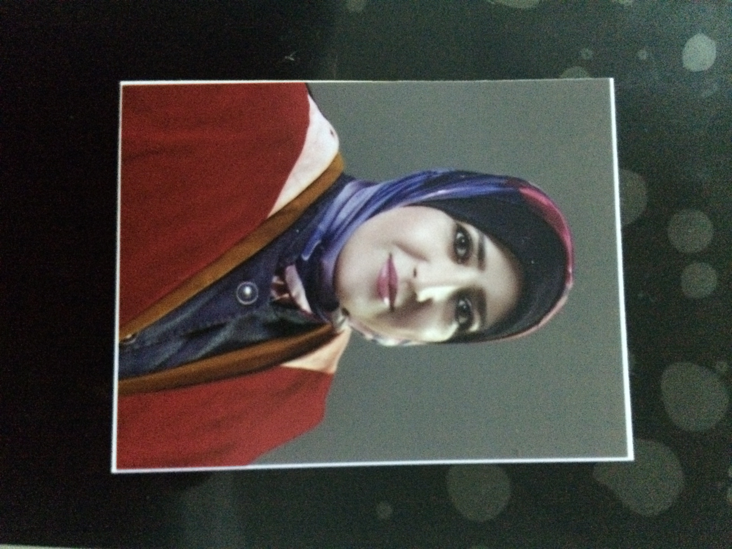
Curriculum Vitae

1
Personal data

Name: Hanan Aref Mesleh Hassan
Nationality: Jordanian
Date and place of birth: Dec.-01-1977 Jerash
Social status: Married
E-mail:jarunih@yahoo.com
Tell. N0 + 962-0772185555
2
Language

Arabic –native
English – Excellent

3
Education

Grade | Date | Country | University | Specialization | Degree
- | 2019 | Paris/ France | AgroParis Tech | Plant Protection/ Fungi | Post Doctorate
Very good | 2016 | Jordan | The University of Jordan | Plant Protection | PH. D
Very good | 2006 | Jordan | University of science and technology. | Agriculture / Plant protection. | Master
Excellent | 1999 | Jordan | Jerash university. | Agriculture/ Plant production and protection. | B .sc.

4
Scientific gradient

Date | Location | Job
2018- 2020  2016-2017  2017-2018  2007-2016  2000-2007 | Jerash university. Faculty of agriculture  Section of plant protection and production  Taiba university. Faculty of science and Arts  Jerash university. Faculty of agriculture  Section of plant protection and production  Jerash university. Faculty of agriculture  Section of plant protection and production | Assistant professor  Assistant professor  Teacher assistance  Lab .supervisor

5
Participation in seminars and scientific conference
Participation | Location and date | Conference | No.
Attendance | Taibah University 2018 | 2nd Scientific meeting | 1
Attendance | Jerash University 2001 | Fourth agriculture scientific conference. | 2
Attendance | Jerash University 2009 | Scientific second day in the college of agriculture. | 3
member of preparatory committee | Jerash University 2010 | Climate change and its impact on agriculture. | 4
member of preparatory committee | Jerash University 2010 | Sustainable agriculture development in Jordan. | 5
Participants | Jordan University 2012 | Biological Control of Ceratitis capitata by Entomopathgenic Fungi | 6
Participants | Jordan University 2012 | A Peroxygenase Pathway Involved in the Biosynthesis of Epoxy Fatty Acids in Oat | 7
Participants | Jordan University 2012 | Does fungal infection influence herbivore-induced  volatile emission in plants? | 8
Participants | Jordan University 2013 | A sustainable approach to control downy mildew  (Bremia lactucae) in Jerash greenhouse-grown lettuce | 9
Participants | Jordan University 2013 | Transgenic Resistance to Crop Diseases | 10
Participants | Jordan University 2013 | Phytohormonal signaling and abnormal growth response  to insect and mites infestation | 11
Participants | Jordan University 2013 | Effects of Benomyl on photosynthesis in Soybean | 12
Participants | Jordan University 2013 | Fungicide impacts on photosynthesis in crop plants | 13
Attendance | Royal botanic garden/  Jordan University 2014 | Proceeding of the international conservation and use of socio economically important wild plants in the fertile crescent | 14
Attendance | Jordan University 2014 | Plant protection association | 15
Participants | Jordan University 2014 | Pesticides in Air | 16
Participants | Jordan University 2014 | Parasitoid Searching Efficiency links Behaviour to Population Processes | 17
Participants | Jordan University 2014 | Detection and Identification for Seedborne Virus  and Tested Methods for Control | 18
Attendance | Royal botanic garden/  Jordan University 2015 | Restoring Degraded Ecosystems: Regional and International Perspectives | 19

6
Membership of committees

Membership date | Name of membership committee | No
2009 | A member of parathion committee for second day of faculty of agriculture  Jerash university. | 1
2007 – 2009  &  2015-2017 | A member of social committee-faculty of agriculture-jerash university. | 2
2011 | A member of parathion committee for fourth day of faculty of agriculture | 3
2014 | A member of Jordan plant protection association | 4
2016/2017 | Coordinated Examinations at the Faculty of Agriculture | 5
2020/2021  2019/2020 | Coordinated of the Department of Pant Production and Protection Examinations at the Faculty of Agriculture | 6

Publish scientific paper
7

Title | #
Assessment of Genetic Diversity among Pleurotus spp. Isolates from Jordan | 1
First record and molecular Identification of Amantia manginiana in Jordan | 2
Biology and Integrated Control of Tomato Wilt Caused by Fusarium oxysporum lycopersici: A Comprehensive Review under the Light of Recent Advancements | 3

Courses and workshops
7

Location and date | Course or workshop | No.
Jerash university 2011 | Teaching strategies cycle | 1
Jerash university 2010 | Measurement and evaluation cycle 2 | 2
Jerash university 2013 | Using interactive panel session | 3
Jordan university 2014 | Scientific day of plant protection | 4
Jerash university 2014 | Agriculture workshop | 5
Jordan university  Research, Training, Extension and Education Institute 2010 | Integrated Pest Managements | 6

8
Teaching activities

Master stage | Under graduate | Teaching courses that I taught | No.
 | 3-credit hours | Principles of plant protection. | 1
 | 3-credit hours | Principles of plant production. | 2
 | 3-credit hours | Plant dieses of Field and horticulture crop | 3
 | 3-credit hours | Pathology Plant | 4
 | 3-credit hours | Genetics plant | 5
 | 3-credit hours | Plant Biotechnology | 6
 | 3-credit hours | Insects of field and horticultural crops | 7
 | 3-credit hours | Nurseries and plant propagation. | 8
 | 3-credit hours | Weeds and their control. | 9
 | 3-credit hours | Environment and agriculture. | 10
 | 3-credit hours | Plant production skills | 11
 | 2-credit hours | Gradation projects research. | 12
 | 3-credit hours | Principles of Edaphology. | 13
 | 3-credit hours | General biology | 14
 | 3-credit hours | Entomology | 15
 | 3-credit hours | zoology | 16
 | 3-credit hours | Diseases of horticultural and crops | 17
 | 3-credit hours | Ecology | 18

* I declare Dr. Hanan Aref Mesleh Hassan that all information on this form are correct and confirm to reality, and in case clearer otherwise take responsibility.

