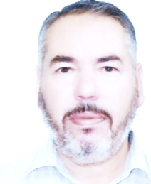

Mohammad Ababneh

Certificates of Appreciation

1. 1st place in UAE in Achievement file.

2. 1st place in UAE in Play writing.

3. 1st place in UAE in Curriculum play.

4. 1st place in Western region in Essay and story writing.

5. Distinguished teacher in educational western region.

Irbid –Eastern Quarter – Al-Zahraa Park

phone: +962781477912

email: mohamedababneh56@gmail.com

Experience

1. 10 Years of teaching in Jordan.

2. 28 Years of teaching in UAE.

3. Chairman of the Council and Coordinator of Arabic Language and its teaching for all academic levels.

Education

Courses

1. Arabic language orientation course.

2.. ICDL

3. Multiple courses in curriculum analysis and writing arts education.

1. Master of Arabic language.

2. BA in Arabic language.

3. Diploma of Arab Language Society College.

Skills  
 1. Short story writing.

2. essay writing.

3. play writing.

Hobbies

1. reading.

2. school broadcast.

3. Curriculum play.

4. Playing sports.