Profile: | Details
Eight years of experience, holds a master’s degree in public health from Mu’tah University, with a variety of experience in various fields such as teaching, supervision, management, and writing scientific research. | Jordan,00962772282184  Rnishraq_s@yahoo.com
Education  Master degree in Public Health Administration) Health Management). (Mutah University) Grade : 91.2%  Bachelor degree in Nursing. (AlHussien Bin Talal University). | Date of Birth:22/5/1992  Nationality: Jordanian  Languages:  Arabic: Mother Tongue  English: Advance

Mrs. Ishraq Nabeel Al-Sarairhe
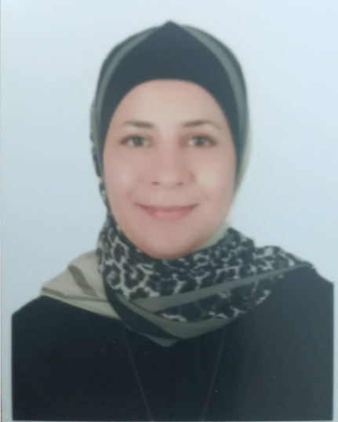

- Employment History
- Full Time Lecturer at Factually of Nursing in Jerash Private University (JPU) from September/2022 until now.

Courses that I taught in Jerash Private University:
- Fundamentals of Nursing (Theory).
- Fundamentals of Nursing (Practicum).
- Adult I of Nursing (Practicum).
- Clinical Nutrition.
- Health Education.

- Clinical Instructor at Factually of Nursing in Jerash Private University (JPU) from July/2022 to August/2022

Courses that I taught in Jerash Private University:
- Adult I of Nursing (Practicum).

- Jordan River Foundation
March-2017 to July-2022
Providing courses in multiple subjects.

- Registered Nurse at Noor ALHussein Foundation, Karak
Dec-2016 to March 2017

- Provide awareness sessions and trainings in different health topics.
- Provided necessary treatment to patients suffering from conditions, such as sepsis, renal failure, diabetic ketoacidosis, and various heart and lung diseases. -Giving lectures and health awareness about public health objects.
- Worked directly with patients to provide care in various critical care units.
- Health Counselor at Save the Children Jordan
Dec-2014 to Feb-2016

- Provide health education sessions in different health topics.
- Assess and prepare care plans for the beneficiaries and refer them based on their needs.

- Volunteer Nurse at Al-Mazar Primary Health Care Center
June-2014 to Dec-2014
Courses
- Attending training course about COVID-19: Tackling the Novel CoronaVirus
- Attending training course about Research Methodologies.
- Attending Course about Quality of Health Care.
- Attending course about Health Polices.
- Attending training course in Statistical Package for Social Sciences (SPSS) .
- Preparation Work Environment Course
- Attending training course about First Aids.
- Work Ethics Course
- Communication Skills Course
- Child Protection Policy Course
- Family Planning Course
- Training of Trainers Course
- Safe Referral Training Course
- Technical and Business Writing Course.
- Health Management

- Title of Thesis: Effectiveness of Nutritional Education Intervention on Adolescent School Girls in Alkarak Governorate, Jordan (2020).

Link: https://search.mandumah.com/Author/Home?author=%D8%A7%D9%84%D8%B5%D8%B1%D8%A7%D9%8A%D8%B1%D9%87%D8%8C+%D8%A7%D8%B4%D8%B1%D8%A7%D9%82+%D9%86%D8%A8%D9%8A%D9%84+%D9%85%D8%AD%D9%85%D8%AF

References:

Dr. Nedal Awad Abed Alnawaiseh
Professor, Factually of Medicine , Mutah University
Email: nawayseh@gmail.com
Mobile Number :0795891817

