Salam Abdullah Ajlouny

Personal Data
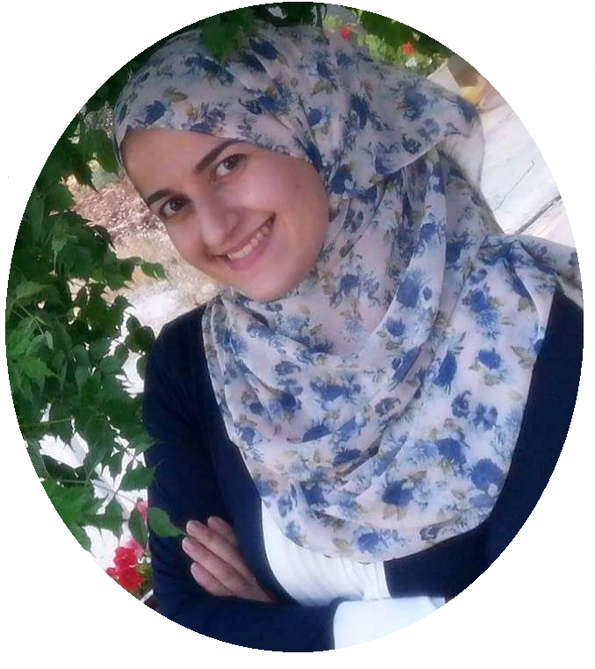
Date of birth: March 2nd 1989

Address: Jordan
Amman - Abu Nsair

Nationality: Jordanian

Marital Status: Single

Mobile: 00962778264194
00962792867157
E-mail: salam.ajlouny@yahoo.com

Education:
Msc. | Master Degree – Transportation Engineering  J.U.S.T university (2014-2016)  Very good – 82%
B.Sc. | Bachelor degree - Civil Engineering
 | J.U.S.T university (2007 - 2012)
 | Good level
GCSE | General Certificate of Secondary Education
 | scientific stream - Jordan (2007)
 | Avarege of 93%

Language skills:
English: Fluent
IELTS exam with 6 band score
Arabic: Mother tounge

Experiences:
- Working at : Jerash Private University (March 2017 – till now )
courses and labs I have taught:

- Transportation Engineering
- Transportation planning
- Geographical Information Systems
- Statics
- Strength of materials
- Reinforced concrete
- Environmental engineering
- Fluid mechanics
- Propability and Statistics for Engineers
- Engineering Mathmatics
- Communication Skills
- Pavement lab.
- Environmental lab.
- Surveying lab.

- Worked at : J.U.S.T university (2014-2017) as a Teaching assitant in Civil Engineering departmet , courses and labs

- Worked at : Abu Al-Haija contracting company, From November 2013 – april 2014 Site Engineer

- Trainined in : King Abdullah II Parks – Irbid , Site Engineer, from 4/10/2012 – 4/4/2013

- Trained in: Al Radaideh Commercial Center – Irbid\Afaq Engineering office; Engineer Ma’mon Khalid Ouqlat , from 25/7/2011 – 29/8/2011

Training Courses

- GIS (Geographic Information Systems) spatial and network analysis at CCST consultative center for science and technology – J.U.S.T
- Primavera (Project manager) at King Abdullah II Fund for Development - J.U.S.T
- EPANET course (water networks) at King Abdullah II Fund for Development - J.U.S.T
- ETABS course (Design high rise buildings using computer) at King Abdullah II Fund for Development - J.U.S.T
- Design of seismic resistant buildings - Engineering Training Center at JEA\Irbid

Research work:

- '' Parking availability at irbid central business district'' case study
under supervision of Prof. Hashem Al-Masaeed

- “ Jordanian Comprehension of Traffic Signs”
under supervision of Dr. Basher H. Al Omari .

- The 6th Traffic Safety Conference /Jordan T.S.C.J on 19-20 November 2012/ Landmark Hotel – Amman.

