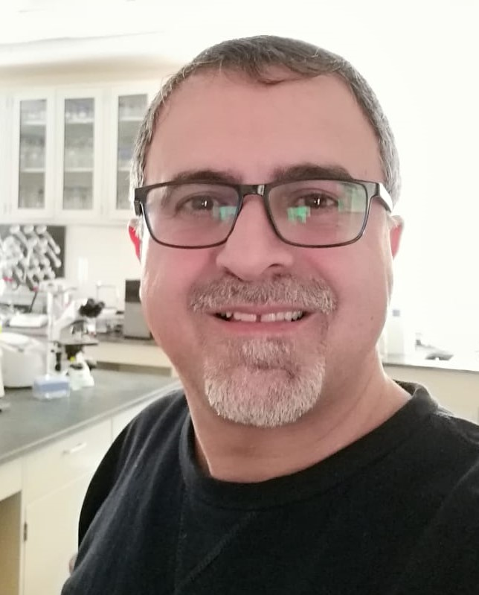 | Curriculum Vitae
- Personal Data:
Name | Nasser M Alshibly | Address | KSA - Jeddah
 |  |  | Jordan - Jarash
Gender | Male | Nationality | Jordanian
D.O. B | 10. Sep. 1969 | Marital Status | Married
Email | Nasserayasrah @yahoo.com | Contact number | +962796863144
- Academic Qualifications:
Year | Degree | Academic Inst, | Field
April -2004 | PHD – Molecular Genetics | Odessa National University-Councle of plant preedingand Genetics Institute | Fitness and crossing over frequency of the mutants Drosophila melanogaster in dependance upon age and artificial reorganizations of a genotype
June-2000 | MBA - Molecular Genetics | Odessa National University | Recombination activety at b-cn-vg chromosome 2 part at Drosophila melanogaster
June-1992 | BA - Biology | Yarmouk University | Biology
- Employment history:
Date | Post | Employer
July 1992 | Teacher | Ministry of Education-Jordan
July 2004 | Assistant Professor | University of Aljabal Algharby-Libya
March 2005 | Assistant Professor | Jarash University
August 2010 | Assistant Professor | King Abdulaziz University- Saudi Arabia
August 2015-now | Assistant Professor | University of Jeddah-Saudi Arabia

- Published Scientific Research:
Author | Title | Journal
Alshibly, Kawstva, Totski | Crossing over frequency of second chromosome at the site b-cn-vg in dependence uponage and enotype. | Odessa national university, Visnik 2001.
Totski, Kawstva, Alshibly, Cechnak | Genobiochemichal mechanism of adaptation. | Cytology and genetics, 2002.
Kawstva, Alshibly, Totski, Blajnova | Recombination frequency as an evidence of genetic balance and fitness of D. melanogaster | Odessa national university Visnik 2004.
N. Alshibly, A.K. Alomari | Explicate series solution for prey-predator problem. Proceedings of the 3rd International Interdisciplinary Chaos Symposium (CCS 2010) | Istanbul, Turkey, 21-24 May 2010.
N. Alshibly | Fitness and crossing over frequency of the mutants Drosophila melanogaster in dependence upon age and artificial reorganizations of a genotype | Research Journal of Biological Sciences, Medwell 2011.
Haytham M. Daradka and Nasser Moh`d Yousef Alshibly | Effect of Artemisia alba L. extract against ethinylestradiol induced genotoxic damage in cultured human lymphocytes | African Journal of Biotechnology 2012.
Majed H. Shtaiwi, Sayed M. Rawi, Nasser M. Alshibly and Mansour A. Alhazimi | Chemical screening and antihyperglycemic property of Cleome droserifolia ethanol extract | Journal of Medicinal Plant Research 2013.
Sayed M Rawi, Nasser M. Alshibly and Fatema Seif El-Nasr | Neurotoxic effect of ciprofloxacin on Albino rat | J App Pharm Vol. 6; Issue 1: 121-132; January, 2014.
Nasser Moh`d Yousef Alshibly | Effect of Artemisia bsinthium L. on Genotoxicity on Mice Bone Marrow Cells | World pplied Sciences Journal 30 (6):770-777, 2014.
Nasser Moh`d Yousef Alshibly | Evaluation of the genotoxic effect of Salvadora persica on mice bone marrow | International Journal of Biological & Pharmaceutical Research. 2017; 8(2): 67-73.
Nasser M. Al-shibly1 , Roushdy M. Mohamed1,2*, Turki M. Al-Shaikh1 , Azza Mahmoud Soliman3 | Study of Commiphora myrrha (Nees) Engl. var. molmol Extract and Its Antibiogram against Some Microbial Pathogens | Egypt. J. Chem. Vol. 65, No. 5 pp. 1 - 10 (2022)
Nasser M. Alshibly¹, Roushdy M. Mohamed² | Ecofriendly Biobutanol Production from Colocasia esculenta (L.) Schott (Talas Liar) Peels Using Submerged Fermentation | Botany and Microbiology Department, Faculty of Science, Al-Azhar University, Cairo, Egypt-2022
- The Scientific Conference:
Date | Conference Title | Paper Title | Location
May 2010 | 3rd International Interdisciplinary Chaos Symposium | Explicate series solution for prey-predator problem. Proceedings of the 3rd International Interdisciplinary Chaos Symposium (CCS 2010) | Istanbul Kutur University
- Workshop and Seminar:
Date | Workshop Title | Participation | Location
2016 | Future aspirations of University of Jeddah under Saudi Arabia’s Vision 2030. | Participate in its initiative | The Center of strategic Studies and Research, University of Jeddah
2018 | Third Student Scientific Forum | Arbitration Committees | University of Jeddah
2018 | Standard of the National Center for Academic Assessment and Accreditation | Scientific Progress | University of Jeddah
2018 | The Meeting on Scientific Research Topics (1440/1439). | Scientific Progress | The Deanship of Scientific Research at the University of Jeddah

- Trainer Courses:
Date | Trainer courses | location
2012 - 2017 | Team Work Skills | Jordan & Libya & Saudi Arabia
2010 - 2014 | Presentation Skills | Jordan & Libya & Lebanon
2010 - 2014 | Time Management | Jordan & Libya & Lebanon
2010 - 2014 | Creative & Innovation | Jordan & Libya
2010 - 2016 | Communication Skills | Jordan & Libya & Saudi Arabia
2014 - 2017 | Problem Solving & Decision Making | Jordan & Saudi Arabia
2014 - 2017 | Developing the Product of Scientific Research by Team Work | Jordan & Saudi Arabia
2017 | Governance In Education | Saudi Arabia
- Training Courses:
Date | Training courses | Location
1996 | Presentation Skills | Jordan
1997 | Microsoft Office | Jordan
1997 | Computer Basic | Jordan
2000 | Statistical Analysis | Jordan
2002 | English Course | Jordan
2004 | Internet & Programs | Jordan
2006 | Team Work Skills | Jordan
2007 | Presentation Skills | Jordan
2007 | Communication Skills | Jordan
2010 | Time Management | Jordan
2016 | Creative Leadership | KSA
2016 | Creative Teaching | KSA
2017 | Academic Accreditation | KSA
2017 | Exams Designing | KSA

- Taught courses:
Courses
General Biology
General Genetics
Human Genetics
Microbiology
Industrial Microbiology
Molecular Biology
Cell Biology
Food Microbiology
Industrial Microbiology
Principles of Biotechnology
Virology
Microbial Biotechnology

- Individual & Language Skills:
Languages skills: |  |  |  |  | Individual Skills
Lang. | Conversation | Reading | Writing |  | Microsoft Office & Internet
 |  |  |  |  | Eng. Language Proficiency in Teaching
ENGL. | Very  good | Very good | Very good |  | E-Learning
 |  |  |  |  | HR Skills
RUSS. | Very  good | Very good | Very good |  | High Communication Skills
 |  |  |  |  | Team Work & Team Spirit

