جامعة جرش  كلية الحقوق |  | Jerash University  Faculty of Law

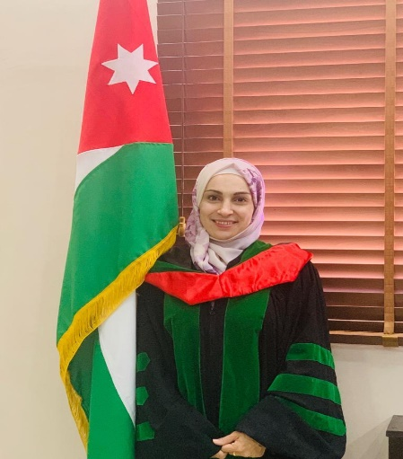

Personal Information:

Date of Birth | Marital Status | Religion | Nationality | The name
2/4/1983 | Married | Muslim | Jordanian | Dr. Alaa Majed Ahmed Bani Younes

Contact information:
Email | Telephone | The Address
a.bneyounes@jpu.edu.jo | 0772272782 | Al Jubeiha

Academic qualifications:
Specialization | University Name | Rating | Graduation Date | Qualified
Law | University of Jordan | Good | 2005 | BA
Private Law | University of Jordan | Very Good | 2010 | Master's
Private/Civil law | International University of Islamic Sciences | Excellent | 2016 | PhD
The title of the doctoral thesis is “The Impact of Intentional Error on the Responsibility of the Insured in the Jordanian Law.”

Experiences:
The Place | Specialization | From – To | Years of work | Position and work
 |  | 2014_2019 | 5 | Ministry of Justice

Scientific Publications:
First: Books:
The Year | Place of Publication | Publication Name | Publication Type
2021/2022 | House of Culture for Publishing and Distribution | Intentional error and its impact on civil law | Book
 |  |  | Peer-review Book

Second: Research papers and scientific conferences.
Indexed in the database | The Year | Volume and Issue | Place of Publication | Research Name | No
Yes | 2019 | Volume 19 Issue 1 | Association for Research and Strategic Studies Aalborg Academy _ Denmark | Virtue provisions in the Jordanian civil law | 1
Yes | 2020 | Volume 115 Issue 17 | USA | Temporal Enforcement of court ruling in the Jordanian law | 2
Yes | 2019 | Volume 19 Issue 2 | Faculty of Law _elbork _ denmark | Preferential Rights on Movable sin Jordanian Civil Law | 3
Yes. scope journal for all fields | 2021 | 11 (12) | Eskisehir osmangazi university, institute of education. Turkey | Deficiencies in the Medical Civil Liability(Q3) | 4
Yes | 2021 | Vol 5 no 4,738-748 | Journal of positive psychology and wellbeing  ISSN:2587-0130 | Uncommon Harms; Neighborhood; Civil Law; Jordan; Civil Liability(Q1) | 5
Yes | 2022 | 2022-vol.6 .no.4,7991-7998-12 | Journal of Positive School Psychology  ISSN: 2717-7564 | Responsibility of objects in Jordanian civil law(Q2) | 6
Yes CLARIVATE ANALYTICS | 2022 | No.309- 105-1-35-11-9-2022 | Journal of law and Political Sciences  ISSN: 2222-7288 | Provision of receivership in the Jordanian civil law | 7
SCPOUS | 2023 | SCPOUS | SEYBOLDREPORT  2023/7/18 | Exoneration from obligation in Jordanian civil law | 8
Scopus | 2024 | 2024 | MIGRATION LETTERS | Legislative Evolution of Cyber Security in Jordanian Law | 9
scopus | 2024 | 2024 | Kurdish studies | The Law Applies to the E-Authentication Service Provider “Comparative Study” | 10

Courses and Seminars:
Date | The place | Title
10/12/2018 | Amman | The National Conference to publish the Jordanian policy paper to raise the representation of women in political parties and electoral lists
10/12/2018 | Royal Cultural Center / Amman | Campaign for the 70th Anniversary of the Universal Declaration of Human Rights
19\11\2018 | Jerash University | International Human Rights Day
6/11/2019 | Jerash University | Arbitration and alternative means of resolving disputes
22-10-2020 | Jerash University | A training course entitled Dealing with computers and smart devices, e-learning and dealing with the global database
29-10-2019 | Jerash University | Symposium on the Jordanian Constitution Amendment, Rights and Duties
17-11-2019 | Jerash University | Arbitration and Alternative Dispute Resolution Conference
November 24 - 2020 | Through the university's electronic platform | Methods for verifying refereed scientific journals classified within global databases
November 21, 2020 | University electronic platform | Mechanism for collecting documents and preparing a self-report for quality standards
7th of November - 2020 | University electronic platform | Training on quality work within the standards of higher education institutions
21 – 8 -2021 | Computer Labs - University Library | Training of faculty members on the use of Ibn Manzur and EBSCO databases

Courses Taught:
The place | Title
Jerash University - Faculty of Law | Introduction to the science of law _ sources of commitment _ provisions of commitment _ named contracts _ rules of civil trials
Jerash University - Faculty of Law | Principles in commercial law - companies and bankruptcy - electronic commerce - insurance contracts - implementation law.

Participation in committees and activities within the university
At the university level:
Member of the Student Disciplinary Council
At the college level:
Chairman of the Student Services Committee
Member of the Investigation, Disciplinary and Grievance Committee
Member of the Measurement and Evaluation Committee
Member of the Local Community Service, Voluntary Work, Awareness and Guidance Committee
Member of the Educational Environment Follow-up Committee
Member of the University Proficiency Examination Committee

Languages:
Reading | Conversation | Writing | The Language
Excellent | Excellent | Excellent | Arabic
Excellent | Excellent | Excellent | English

