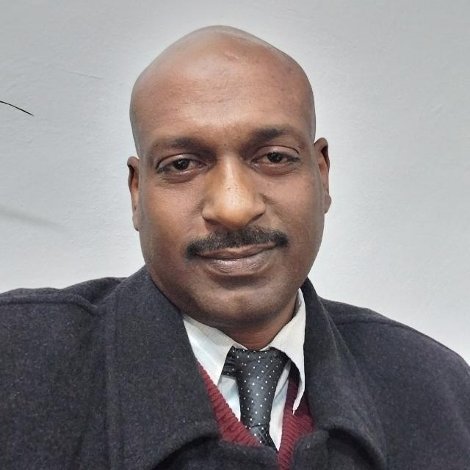 Curriculum Vitae
NAME | Hassan Mubarak Hassan Abdelnour.
ADDRESS | Jerash University  Faculty of Applied Medical Sciences  Physiotherapy Department.  Jerash – Jordan.  Cell phone number: +962795152648.  Email address: hasphysio@gmail.com  ORCID ID: https://orcid.org/0009-0001-9873-5966
OTHER DETAILS | - Sex: Male  - Date of Birth: 26th November 1974  - Nationality: Sudanese  - Marital Status: Married (two daughters)  - Languages: Arabic – Fluent  English – Good
STATISTICS AND COMPUTER PACKAGES: | - MICROSOFT OFFICES  - SPSS
CAREER OBJECTIVES | To obtain a challenging position in my field, with goal to enhance, adapt and apply current research and technology that supports lifelong personal and professional development.
EDUCATION | - (2002)-BSc in Physiotherapy.  Dagupan Colleges Foundation.  Philippines.  - (2009)-MSc in Physiotherapy.  University of the Western Cape.  South Africa.  - (2020)- PhD in Physiotherapy.  University of the Western Cape.  South Africa.
TRAINING  WORK EXPERIENCE | - Khartoum Teaching Hospital – Khartoum - Sudan.  - Usratuna School. Children Disability Department – Juba – South Sudan.  - Geravasutta Rehabilitation Hospital – Udine – Italy.  - National Authority for Prostheses and Orthoses – Khartoum – Sudan.  - Military Hospital - Khartoum – Sudan.  - University of Western Cape, Postgraduate Enrolment and throughput (PET) Project – Cape Town – South Africa.  - (2002 – 2005) Physiotherapist. Khartoum Cheshire Home for Disable Children - Physiotherapy Department. Khartoum – Sudan.  - (2005 – 2017) Physiotherapist. Al Salama Physiotherapy and Rehabilitation Centre. Khartoum – Sudan.  - (2022 till now) Assistant Professor. Jerash University - Physiotherapy Department – Jerash - Jordan. (2020 - 2022) Assistance Professor. (2005 - 2020) Lecturer. (2005-2008) Physiotherapy Coordinator. (2012 – 2014) Physiotherapy HOD. Ahfad University - Physiotherapy Department – Khartoum – Sudan.  - (2010 – 2011) Lecturer –. Bergen University Colleges – Bergen – Norway.  - (2009 – 2018) Lecturer. (2019 - 2022) Assistance Professor. Ibn Sina University - Physiotherapy Department - Khartoum - Sudan.  - (2019 - 2022) Part timer senior physiotherapist. National Authority for Prostheses and Orthoses (NAPO) - Khartoum - Sudan.  - (2009 – 2014) On call physiotherapist for In-Patients. Fidel Hospital - Zaitona Hospital - Al Arbaeen Hospital. Khartoum - Sudan.  - (2009 – 2014) Head of Physiotherapy Department at Aroma Medical Center - Khartoum - Sudan.
PROFESSIONAL SKILLS | - Good English and Arabic language in writing and reading.  - Studies and Researches.  - Curriculum design and Evaluation.  - Data Analysis and Evaluation.  - Knowledge Building and Reporting.  - Good knowledge in Computer.
ATTENDED COURSES, CONFERENCES, AND WORKSHOPS  RESEARCH ACTIVITIES | - Pensotti technique for treating Club Feet under Dr. Steve Mannion, Khartoum, Sudan. 2005.  - University of the Western Cape Post Grad Research Workshops for Masters and Doctoral Students SPSS workshop, on 5 Jun 2006.  - University of the western Cape Postgraduate Enrolment and throughput (PET) Project SPSS Short Course Day on 5-7 August 2008 Cape Town, South Africa.  - Fredskorpset exchange program between Norway and Sudan, February 2011, Fredricstad, Norway.  - World Conference for Physical Therapy (WCPT) in 2011, Amsterdam, Netherlands.  - World Conference for Physical Therapy (WCPT) in 2017, Cape Town, South Africa.  - World Conference for Physical Therapy – Africa (WCPT-A) in 2012, Nairobi – Kenia.  - Jordan Medical Association – The 6th International Medical Congress of the Sub Committee of the Medical Association – 2023, Ajloun – Jordan.  - Physiotherapy and Medical Technology role form assessment into Treatments – Faculty of Applied Medical Sciences – 2023- Jerash University – Jerash – Jordan.  - Profile of individuals with physical disabilities to assist the development and implementation of appropriate services in Khartoum State. Abdelnour, H. Rowe, M. Rhoda, A. Van den Bergh, G. Poster presentation at Disability and Global Health - Implications for Rehabilitation - Bergen – Norway 23 – 25 June 2016.  - Continuing Professional Development in Physiotherapy through a Multi-Institutional Partnership: Ahfad University for Women Perspective. Salih, O. Alameen, R. Abdelnour, H. Poster presentation at Disability and global health - Implications for rehabilitation - Bergen – Norway 23 – 25 June 2016.  - Rawia Osman, Hassan Abdelnour, Amira Elaalem. (2024). Physiotherapy use of Paraffin Wax for Rheumatoid Arthritis in Sudan. International Journal of All Research Education and Scientific Methods, 12(8): 2455-6211  - Abdulmajeed Almalty, Saja Hamed, Mohammed Jebril, Hassan Abdelnour. (2024). The effect of electrical stimulation on skin vulnerability to irritants. Skin Res Technol, 30: e13591. DOI: 10.1111/srt.13591  - Hassan Abdelnour, Nermeen Bleedy, Abdulmajeed Almalty, Asrar Elkhir, Maria Ayoub. (2024). Using 3Dimensional Teaching in Biomechanics for Physiotherapy Education at Ahfad University for Women, Sudan. Journal for ReAttach Therapy and Developmental Diversities, 7(1): 01-07. ISSN: 2589-7799  - Nema Bushra, Roula Francis, Hassan Abdelnour, Nermeen Bleedy. (2023). Effectiveness of Mirror Therapy for Amputation Patients at National Authority of Prosthesis and Orthosis in Sudan. Polish Journal of Physiotherapy, 5(23): 253-257.  - Hassan Abdelnour & Mariana Bolis. (2023). Clinical Placement and Clinical Skills at Ahfad University for Women Physiotherapy Education. International Journal of Current Research, 15(12):26650-26653. ISSN: 0975-833X  - Hassan Abdelnour, Ismail Abdellatif, Pang Ismail, Tsabeeh Jondi. (2023). Facts Related to the Prevalence of Sports Injury at Ahfad University for Women in Sudan. International Journal of Novel Research in Interdisciplinary Studies, 10(6): 20-26. ISSN 2394-9716  - Abdulmajeed Almalty, Hassan Abdelnour, Mohannad Hawamdeh, Shadi Alkhob. (2023). Physiotherapists’ Understanding of Shortwave Diathermy Contraindications: A Questionnaire Survey. Risk Management and Healthcare Policy, (16): 1171 - 1185.  - Tariq Abdalmagid, Hassan Abdelnour, Rashed Aladwan. (2023). Physiotherapy Students and Clinical Education in Sudan. International Journal of Novel Research in Healthcare and Nursing, 10(3):197-201. DOI: https://doi.org/10.5281/zenodo.10046022  - Balsam Mohamed Abdallha Fadlallha, Rashed Aladwan, Hassan Abdelnour. (2023). Knowledge of Physiotherapy among Final Year Students Faculty of Medicine in Universities at Khartoum State, Sudan. International Journal of Innovative Research & Development, 12(8): 125 – 130. DOI: 10.24940/ijird/2023/v12/i8/AUG23013  - Abdelnour Hassan, Haidy Crisian, Mariana Bolis, & Mekdes Aschalew. (2023). Clinical Placement effectiveness on Physiotherapy Students at Ahfad University in Sudan. International Journal of Education and Research, 11(9): 135 - 142. ISSN: 2411 - 5681.  - Hassan Abdelnour, Abuelgasim Mohamed, Duaa El Tigani, Balsam Abdallha. (2023). Physical Disabilities and Rehabilitation Services in Khartoum State, Sudan. The International Journal of Humanities & Social Studies, 11(9): 79 – 83. ISSN 2321 – 9203. DOI: 10.24940/theijhss/2023/v11/i9/HS2309-016
PERSONAL SKILLS | - Quick learner.  - Hard worker.  - Good communication skills.  - Active team work player.  - Believe In Creativity and Innovativeness.  - Good Command in English.
EXTRA  CURRICULAR  ACTIVITIES  HOBBIES | - Sports.  - Travelling.
REFERENCES | - Prof. Anthea Rhoda  Dean of Faculty of Community and Health Science  University of the Western Cape  Bellville 7535, South Africa  Email: arhoda@uwc.ac.za Tel: +27827757748  - Prof. Graziella Van den Bergh  Faculty of Health and Social Sciences  Western Norway University for applied Sciences  Bergen, Norway  Email: Graziella.Van.den.Bergh@hvl.no Tel: +4755585639  - Prof. Osama Awad  Dean of School of Health Sciences.  Ahfad University.  Khartoum, Sudan  Email: osamaawadsalih@gmail.com Tel: +249900335856  - Dr. Zakariya Mohammed  Assistant Professor, Advisor to Vice-President for Scientific Research and Postgraduate Studies  Northern Border University  Arar, KSA  Email: zakariyamohammed@gmail.com Tel: +966559792160

