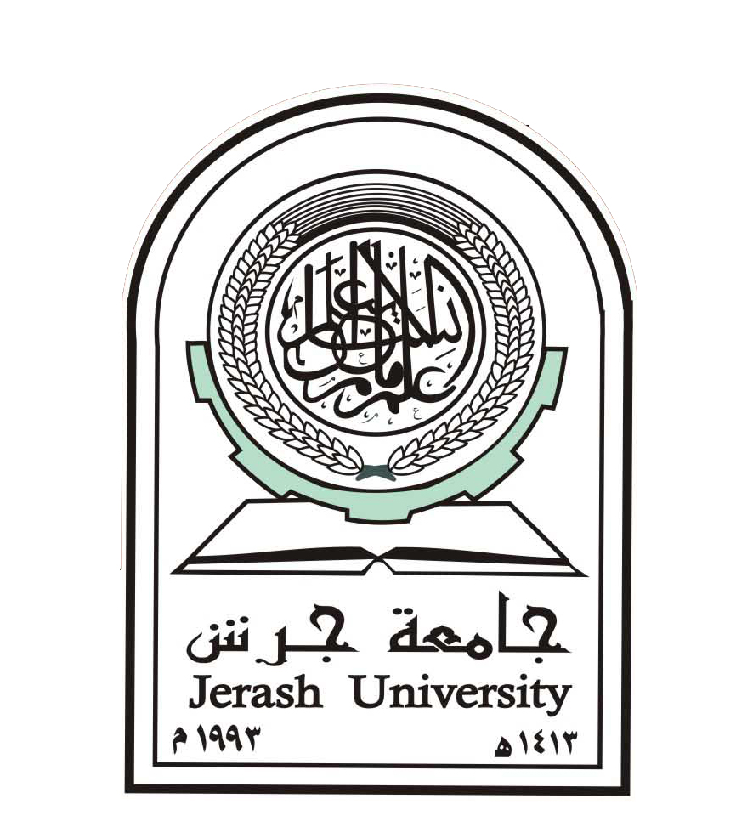

College: Engineering Department: Civil

Course Title: Water Resources

Course No:0901518

Credit Hours: 3hr

Semester:2018/second

About The Course

Course Title: Water Resources Class:A
Course No:0901518
Credit Hours: 3hrs Lecture Room:410

Obligatory/ Optional:
Text Book: Principles of Integrated Water Resources Management, Pieter van der Zaag and Hubert H.G. Savenije 2015

The Instructor

Name: Dr Mohammad Fawzi al ajlouni Title: Assistant Professor
Office Tel:000000000
Office No:13 Office Hours:8

E-maile: mohammad-fawzi@engineer.com

Course Description
Assessment of surface and groundwater resources, water resources planning, water resources management, water demand management, integrated water resources management, water resource systems

Course Objectives
1.To prepare the students for a successful career as water professionals.
2. To develop the ability among students to synthesis data and technical concepts for application in Integrated Water Resources Management.
3. To provide students an opportunity to work as a part of an interdisciplinary team.
4. To provide students with a sound foundation in the mathematical, scientific and engineering fundamentals necessary to formulate, solve and analyze engineering problems and to prepare them for their career.
5. To promote student awareness for the life-long learning and to introduce them professional ethics and codes of professional practice in water resources management.
Learning Outcome
1-An ability to choose and use Research methodologies, Integrated Water Resources Management and gender relations and roles, legal aspects as it applies to the field of Water Resources Management.
2. An ability to design and construct environmental, socio-economical, water governance, political, ethical, health and safety, and sustainability.
3. An understanding of professional, institutional arrangements, legal and ethical issues, and responsibilities to water resource management.
. 5. The necessary to understand the impact of water and water related issues in a global, economic, environmental, and societal context.
Course Outline and Time schedule

Course Outline | Week
Course review and introduction | First week
Water management and water governance basics | 2nd week
Watershed Conservation and Management | 3rd week
Water Usage for Domestic , Industrial , Irrigation | 4th week
Water quality and monitoring | 5th week
Conservation and planning | 6th week
Water security and international development | 7th week
Water Budget | 8th week
Jordan water Resources | 9th week
Water Budget in Jordan | 10th week
Storm water Management | 11th week
Water storage in Jordan | 12th week
Flooding Management | 13th week
ASR as Tools of IWRM | 14th week
General Review | 15thweek

Presentation methods and techniques
Methods of teaching varied according to the type of text, student and situation. The following techniques are usually used:

- Lecturing with active participations.
- Problem solving.
- Cooperative learning.
- Discussion.
- Learning by activities.
- Connecting students with different sources of information

Sources of information and Instructional Aids

Computer … power point
- Transparencies
- Library sources

Assessment Strategy and its tools

The assigned syllabus is assessed and evaluated
Through: feedback and the skills that are acquired by the students

The tools:
- Diagnostic tests to identify the students level and areas of weakness
- Formal (stage) evaluation
a) Class Participation
b) Ist Exam
c) 2nd Exam
d) Activity file

Tool & Evaluation

Tests are permanent tools & assessment, in addition to the activity file which contains curricular and the co-cussiculor activities, research, report papers and the active participation of the student in the lecture.

The following table clarifies the organization of the assessment schedule:

Grade | Date | Test
20 |  | First Exam
20 |  | 2nd Exam
20 | Students should be notified about their marks | Activities & Participation
40 |  | Final Exam

Activities and Instructional Assignment

- Practical assignments to achieve the syllabus objectives.
- ……..

Regulations to maintain the teaching-Learning Process in the Lecture:
1- Regular attendance.
2- Respect of commencement and ending of the lecture time.
3- Positive relationship between student and teacher.
4- Commitment to present assignments on time.
5- High commitment during the lecture to avoid any kind of disturbance and distortion.
6- High seuse of trust and sincerity when referring to any piece of information and to mention the source.
7- The student who absents himself should submit an accepted excuse.
8- University relevant regulations should be applied in case the studen,s behavior is not accepted.
9- Allowed Absence percentages is (15 %).

Internet websites
1 www.pdfdrive.com….
2 www.springer.com…….
3 www.sciencedirect.com……..

References :
- Webler&Tuler (2001)
- Ongley (2000)
- Wolf (2005); Jønch-Clausen and Fugl (2001)
- .Budds&McGranahan (2003)
- Richter et al. 2010
AYSEGUL TANIK et al. 2013
Syllabus Classification

Objectives | Learning outcome | Assessment tools
1-
2- 2-
3-
4-
5-

