
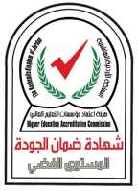

Jerash University Faculty of Educational Sciences
Graduate Studies Higher Diploma in Educational Management

Higher Diploma Plan in Educational Management

Course Number | Course Name | Hours |  | Course Number | Course Name | Hours
Number of hours (27) hours
1- Compulsory requirements (18) hours |  |  |  | 2- Elective requirements (9) hours
705610 | Educational Administration | 3 |  | 705630 | Classroom Management and Organization | 3
705616 | Educational Research Methods | 3 |  | 705635 | Principles of Educational Supervision | 3
705620 | Educational Planning | 3 |  | 705637 | Human Resource Management | 3
705622 | School Administration | 3 |  | 705639 | Total Quality Management | 3
705625 | Organizational Behavior in Educational Institutions | 3 |  | 705640 | Educational Policies | 3
705627 | Educational Leadership | 3 |  | 705642 | Administrative Training | 3

